DEERFIELD MVP CLIMATE RESILIENCY PLAN UPDATE
2025
under a Municipal Vulnerability Preparedness grant from the Massachusetts Executive Office of Energy and Environmental Affairs
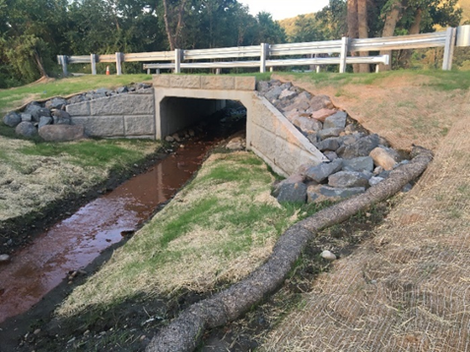
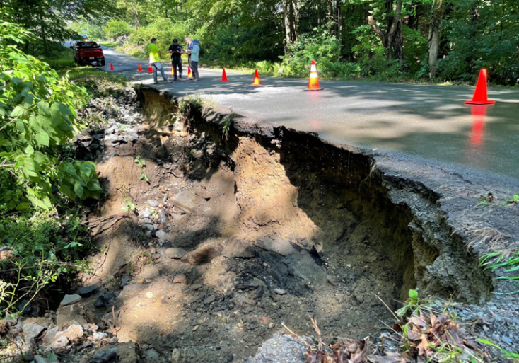

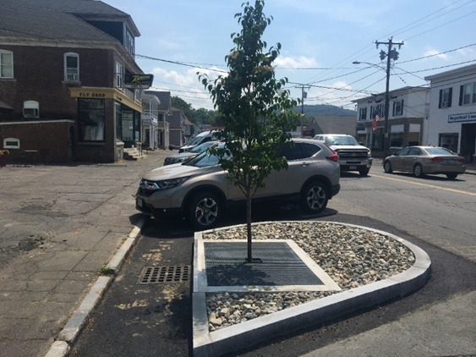
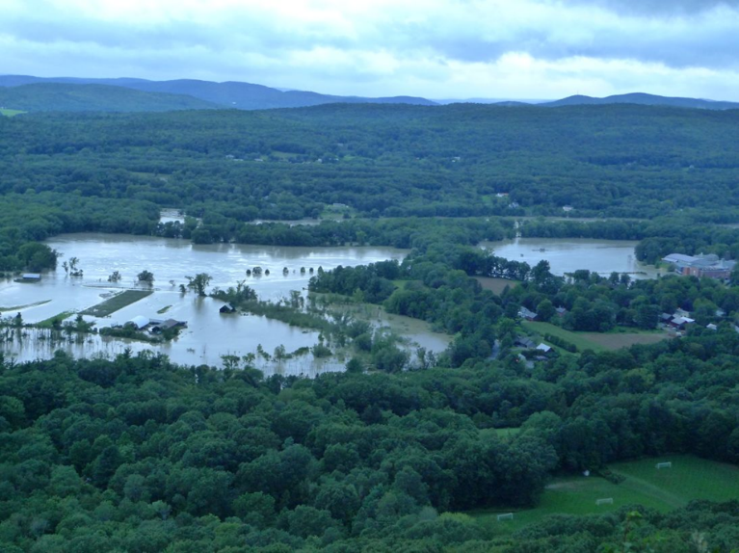

DEERFIELD MVP CLIMATE RESILIENCY PLAN UPDATE
2025

Acknowledgements

This project was funded under a Municipal Vulnerability Preparedness grant from the Massachusetts Executive Office of Energy and Environmental Affairs.

Thanks to the following members of the Deerfield MVP Core Team:

- Carolyn Shores Ness, Chair, Deerfield Selectboard
- Tim Hilchey, Deerfield Selectboard
- Chris Nolan, Deerfield Assistant Town Administrator
- Denise Mason, Deerfield Planning Board
- Peter Law, Deerfield Conservation Commission
- Cece Yazwinski, student liaison
- Henry Melnik, farming liaison
- MA Swedlund, senior citizen liaison
- Laurie Boosahda, teacher liaison
- Kevin Scarborough, Deerfield DPW Superintendent (non-voting, ex officio)
____________________________________________________________________

Report prepared for the Town of Deerfield by:
- Christopher Curtis, Conservation Works
- Wayne Feiden, Plan Sustain

1. OVERVIEW
Deerfield’s Track Record of Success with Municipal Vulnerability Preparedness (MVP) Grants

Deerfield was the first community in Massachusetts to become a certified Municipal Vulnerability Preparedness (MVP) community in 2018.

Between 2017 and 2024, the Town of Deerfield applied for, and received, seven MVP grants totaling $1,708,060 from the Massachusetts Executive Office of Energy and Environmental Affairs (EOEEA), including two planning grants and five action grants that funded 23 projects, ranging from green infrastructure to regional climate forums to school climate curriculum.

Fiscal Year | Grant Type | Amount | Components
FY17 | Planning | $15,000 | Workshop and action plan
FY18 | Action | $66,936 | Mill Village Road culvert design, floodplain zoning bylaw
FY19 | Action | $389,069 | Mill Village Road culvert construction, design for replacement culvert on Kelleher Drive, engineering designs for tree box filters and rain gardens for town center and schools, coordinate “Climate Resiliency: Deerfield 2030 Forum”, more.
FY20 | Action | $769,145 | Construction of Kelleher Drive culvert, design and construction of green infrastructure in Deerfield Town Center, Historic Deerfield and at schools, Frontier High School student engagement on climate resiliency, zoning for climate resiliency
FY22 | Action | $64,523 | Green Infrastructure Policy implementation, Frontier Climate Science curriculum, Healthy Soils Pilot Demonstration project, Community Climate Resiliency Forum,Climate Resiliency Website
FY24-25 | Action | $308,387 | Construction of green infrastructure for Historic Deerfield, construction of green infrastructure at Town Center Leary Lot, construction of green entryway at Deerfield Elementary School
FY25 | MVP 2.0 Planning | $95,000 | Updated MVP Action Plan  Implemented Seed project
FY25 | Action | $170,300 | Deerfield Bloody Brook Resilience
TOTALS |  | $1,878,360

2017 MVP Planning Grant

The Town of Deerfield applied for and received an MVP planning grant in 2017. The town applied for this grant to better prepare the community for climate change and to reduce vulnerability and increase resilience to climate related events, in particular flooding impacts from the Deerfield River. The grant provided funding for a Community Resilience Building workshop, which was held on January 24, 2018. It also funded the development of the town’s MVP Climate Resiliency Plan. Deerfield’s MVP Plan was approved by EOEEA in 2018, making Deerfield the state’s first MVP-certified community.

2018 Action Grant
Components of this $66,936 Action Grant included:
- Design and Permitting for Replacement Culvert on Mill Village Road
- Update the Town’s Floodplain Zoning Bylaw and MVP Plan, and Seek Formal Adoption

2019 Action Grant
Components of this $389,069 Action Grant included:

- Construction of Replacement Culvert on Mill Village Road
- Design and Permitting for Replacement Culvert on Kelleher Drive at Bloody Brook
- Engineering Designs for Tree Box Filters and Rain Gardens for Town Center and Schools
- Coordinate “Climate Resiliency: Deerfield 2030 Forum”
- Public Education on New Rave Alert System
- Evacuation Action Plan for Great River Hydro Emergencies
- Land Conservation in Deerfield River Floodplain

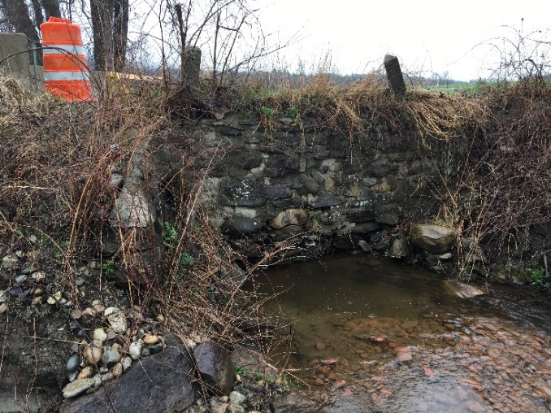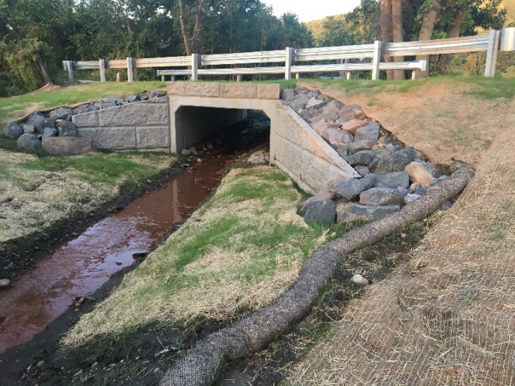

Mill Village Culvert: Before Mill Village Culvert: After

2020 Action Grant
Components of this $769,145 Action Grant included:
- Construction of Replacement Culvert on Kelleher Drive at Bloody Brook
- Task 2: Construction and Installation of Green Infrastructure in Deerfield Town Center and at Schools
- Design for Green Streets and Green Parking Lots in Town Center, Schools and Historic Deerfield
- Frontier High School Student Engagement on Climate Resiliency
- Comprehensive Review of Town Bylaws and Regulations to Promote Climate Resiliency and Mitigate Climate Impacts
- Develop Site Plan Review Amendments to Promote Greener Development

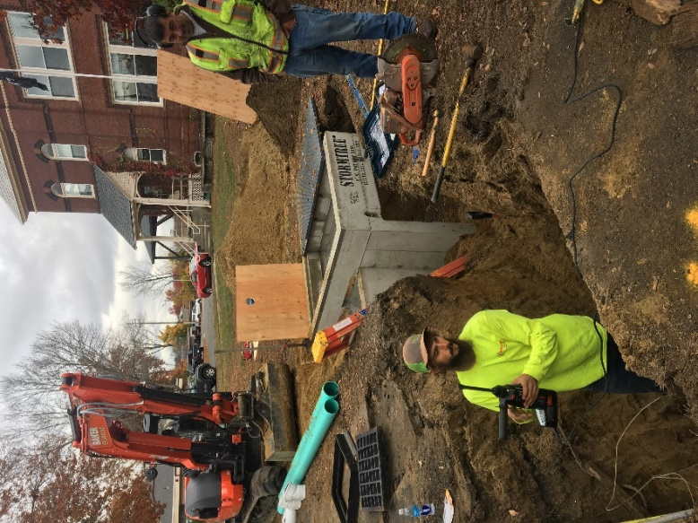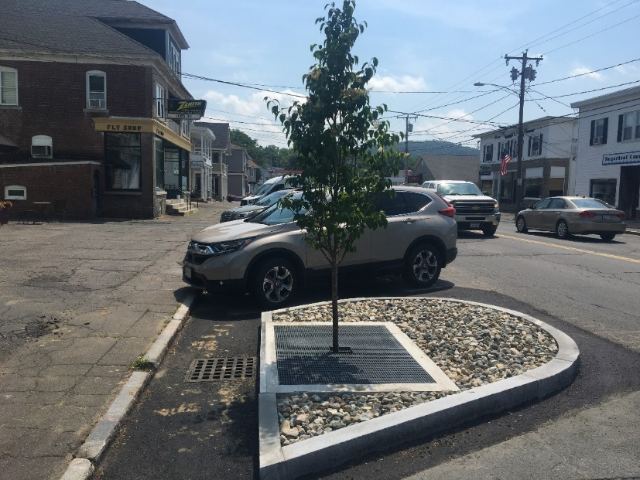
Tree box filter installations in the center of South Deerfield

2022 Action Grant
Components of this $64,523 Action Grant included:
- Green Infrastructure Policy Implementation
- Frontier Climate Science Programming and Engagement
- Healthy Soils Pilot Demonstration Project
- Community Climate Resiliency Forum
- Climate Resiliency Website

2024-5 Action Grant
Components of this $308,387 Action Grant included:
- Construction of Green Infrastructure for Historic Deerfield
- Construction of Green Infrastructure at Town Center Leary Lot
- Construction of Green Entryway at Deerfield Elementary School

2024 MVP 2.0 Grant

This grant provided funding to broaden public engagement in the town’s MVP process, expand the town’s MVP Climate Resiliency Core Team, overhaul and update this MVP Plan, and undertake a set of seed projects.

2025 Action Grant

This grant provided funding to undertake a watershed analysis of the Bloody Brook watershed to understand the root causes of flooding problems.

2. MVP 2.0 PLanning Process

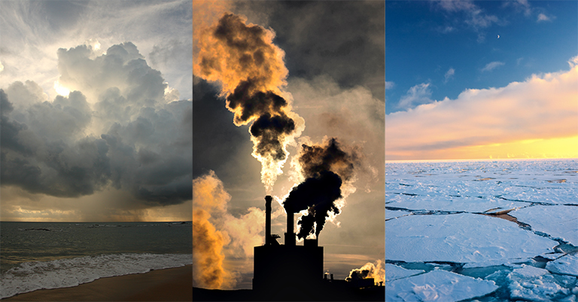

2a) MVP Core Group
Deerfield’s MVP Climate Resilience Core Group has been guiding the town’s MVP process for seven years. As part of the MVP 2.0 process, the Core Group was expanded to include representatives from groups not previously involved, including seniors, farmers, students and teachers. The group also has representatives from town boards and administration, including the Selectboard, Planning Board, Conservation Commission, Public Works and the Assistant Town Administrator.
2b) Core Group Training
Deerfield’s MVP Climate Resilience Core Group completed two sets of Climate Resilience trainings:
- Climate Resilience Training
- Equity and Climate Justice Learning Series
The Core Group completed the three Climate Resilience trainings in January and February, 2024. These trainings acquainted Core Team members with the climate projections data in Resilient MA, facilitated discussions about local climate vulnerability and building community climate resilience, and informed the Social Resilience Roadmap prepared by the core group.
2c) Uncovering Social Resilience
The core group adopted their Social Resilience Road Map (Part A) to identify those with lived experience, based both on detailed knowledge of Deerfield and extensive analysis of demographic and economic data. After some of the climate resilience trainings, extensive discussion, and interviews of stakeholders and those with lived experience, the core group adopted their Social Resilience Road Map (Part B) to investigate community vulnerability and resilience.
2d) Revisiting Community Resilience Priorities and Community Engagement Activities
The Deerfield MVP Core Group updated community resilience priorities. They started with building on the 2018 MVP planning, the Social Resilience Roadmap, and the core group’s own lived experience and knowledge. With this analysis, they then sponsored a community forum with outreach to diverse stakeholders with lived experience to expand their understanding and analysis and build on community experience.
Additional community engagement activities included participation with Food Pantry and Senior Center events, a Farmers Forum, student engagement at Frontier Regional School and Deerfield Elementary School, interviews with underserved stakeholders and townwide survey results.
The final revised community resilience priorities update this MVP Plan to help Deerfield plan for future resilience actions, whether funded by MVP, FEMA, other grants or Town funding and in-kind resources.
2e) Selecting a Seed Project
The Core Group identified two seed projects after considering the updated community resilience priorities. They focused on projects that addressed these priorities, were possible given the MP 2.0 budget and timeline, and would help build community momentum.
2f) Implementing Seed Projects
The Core Group implemented two seed projects, including:
Seed Project #1: Sugarloaf Brook Watershed Study
  - Hydrologic and hydraulic study of watershed
  - Geomorphic assessment of watershed
  - Recommendations for addressing flooding, including identifying which culverts create the greatest risk of causing flooding and/or road damage
  - Community engagement in study and results
Seed Project #2: Deerfield River Land Protection
- Work with landowners to identify those willing to protect prioritized Deerfield River floodplain lands

3. climate change projections for Deerfield

3a) Climate Change is a Reality
In Massachusetts, and in Deerfield, the climate is already changing. Evidence of this change is shown in the following statistics:
- Temperature: has increased 2.9 degrees since 1895
- Growing season: has increased 11 days since 1950
- Sea level rise: 11 inches since 1922
- Strong storms and peak precipitation: 55% increase since 1958
- Weather is increasingly unpredictable
- Tick Borne Diseases: have increased steadily in Massachusetts, especially Lyme disease (CDC)

Multiple studies published in peer-reviewed scientific journals show that 97 percent or more of actively publishing climate scientists agree climate-warming trends over the past century are extremely likely due to human activities. This climate warming trend is related to the greenhouse effect, which is illustrated below:

Climate projections for Massachusetts indicate that warming will result in:
- By mid-century Massachusetts climate will be similar to northern Virginia
- By end of century like South Carolina
as illustrated on the map below:

3b) Temperature Changes
Projected temperature changes for Massachusetts indicate the following changes in summer and winter temperatures:
- Summer is expected to see an increase in days over 90 °F. from a baseline of 6 days to 10-35 more days by mid-century, and 15-76 more days by end of the century;

- Winter will have 23-60 fewer days below freezing by the end of the century.

3c) Temperature Change Impacts
The impacts of rising temperatures will include:
- More heat in the summer will put larger cooling demands on aging systems, creating the potential for power outages, with increased electric use potentially partially balanced by a move to more efficient heat pumps;
- Urban residents– especially very young, ill, and elderly – will face greater risks of serious heat-related illnesses, especially in older housing without air conditioning and lower income neighborhoods with fewer street trees and more heat island issues;
- Rising winter temperatures will have economic impacts on winter recreation industry (e.g. skiing) and will result in increased insect pests as fewer insects (especially ticks) die off in the winter, and larger heating demands on aging electric and other systems.

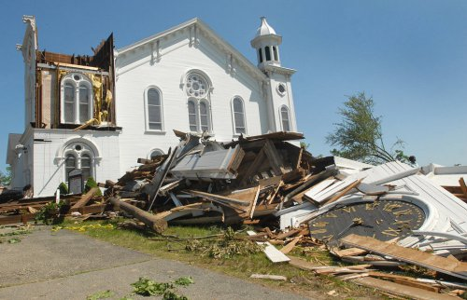
Tornado damage in Monson, MA

3d) Rainfall Changes and Impacts
Along with rising temperatures, projections indicate major changes in rainfall trends and impacts, including:
- Frequency and severity of high-intensity rainfall events will trend upward
- Days with rainfall over 1” will increase from a baseline of 6 now, by 1-4 days by end of century
- More intense downpours often lead to inland flooding and reduced opportunities to capture rainwater in surface water bodies and groundwater
- More intense downpours also increase the volume of debris being carried in streams and rivers during periods of high water, increasing blockages at culverts, bridges, and other obstacles
- Winter precipitation increases, more in form of rain
- Summer precipitation decreases and could combine with higher temperatures to increase the frequency of episodic droughts
- Summer droughts are likely to increase in length from an average of 16 days, by 1-3 days
- Droughts will create challenges for local water supply by increasing evaporation, reducing surface water storage and the recharge of groundwater supplies

3e) Resilient Mass Climate Change Projections for Deerfield

The following tables illustrate projects climate changes for heat, cold and precipitation specific to Deerfield, Massachusetts, from the Resilient Mass website, created by the Massachusetts Executive Office of Energy and Environmental Affairs.
AVERAGE AND COLD DAYS
 | Minimum  Temperature | Average Duration of Coldwaves | Number of Coldwave Events | Days Below 0 degrees F | Average Temperature | Maximum Duration of Coldwaves | Number of Coldstress Events | Heating Degree Days | Days Below 32 degrees
Baseline Value | -12.9 degrees F | 13 days | 1 | 20 days | 43.1 degrees F | 21 days | 113 | 8209 | 180 days
2030 | +3.6 degrees | -1 | 0 | -8 | 3.6 degrees | -6 | -23 | -1093 | -25
2050 | +6.3 degrees | -2 | 0 | -11 | 6.3 degrees | -8 | -39 | -1843 | -48
2070 | +9 degrees | -2 | 0 | -14 | 9 degrees | -9 | -53 | -2540 | -68
2090 | +10.8 degrees | -2 | -1 | -16 | 10.8 degrees | -10 | -63 | -2979 | -79
Source: Massachusetts Executive Office of Energy and Environmental Affairs, Resilient Mass Climate Change Projections Dashboard
Note: Degrees Days = Difference between daily temperature mean and 65 degrees. Example: 78 degrees – 65 degrees = 12 cooling degree days

HOT DAYS
 | Maximum  Temperature | Days Above 95 degrees | Number of Heat Stress Events | Average Duration of Heatwaves | Cooling Degree Days | Days Above 90 Degrees F | Days Above 100 Degrees F | Number of Heatwave Events | Maximum Duration of Heatwaves | Growing Degree Days
Baseline Value | 79.6 degrees | 0 days | 0 | 0 | 199 | 1 day | 0 | 0 | 0 | 2208
2030 | 3.6 degrees | 0 | 0 | 0 | 222 | 5 | 0 | 0 | 0 | 518
2050 | 6.3 degrees | 2 | 0 | 0 | 455 | 12 | 0 | 0 | 0 | 936
2070 | 9 degrees | 6 | 0 | 0 | 744 | 26 | 0 | 0 | 0 | 1370
2090 | 10.8 degrees | 12 | 1 | 9 | 963 | 38 | 1 | 0 | 0 | 1669
Source: Massachusetts Executive Office of Energy and Environmental Affairs, Resilient Mass Climate Change Projections Dashboard

PRECIPITATION
 | Total Precipitation | Maximum Precipitation | Days Above 2” | Consecutive Dry Days | Precipitation Depth, 90th Percentile Storm Rainfall | Precipitation Depth, 99th Percentile Storm Rainfall | Days Above 1” | Days Above 4” | Consecutive Wet Days
Baseline Value | 52.6 inches | 2” | 1 day | 27 days | .4” | 1.2” | 6 days | 0 days | 43 days
2030 | +6% | 9.1% | 0 | 0 | 1.1% | 6.5% | 1 day | 0 | 0
2050 | +8% | 17.2% | 0 | 1 | 1.6% | 12.1% | 2 days | 0 | 1
2070 | +9.8% | 26.8% | 1 | 2 | 1.9% | 18.5% | 2 days | 0 | 2
2090 | +12.1% | 34% | 1 | 3 | 1.8% | 23% | 3 days | 0 | 2
Source: Massachusetts Executive Office of Energy and Environmental Affairs, Resilient Mass Climate Change Projections Dashboard

The 2022 Massachusetts Climate Change Assessment report summarized some of the key climate changes and resulting impacts for the Connecticut River valley as shown below.
Regional Climate Outlook: Connecticut River Valley
2030 | 2050 | 2070 | 2090
NEAR TERM The summer mean temperature could increase by 3.6°F from the historical period (1950-2013), causing impacts to local crop yields and food security | MID-CENTURY The 1 percent annual chance river flood could be three times more likely to occur, increasing Connecticut River and other area flood risk | MID-LATE CENTURY There could be 65 fewer days below freezing, increasing the chance of ticks overwintering and reducing winter recreation opportunities. | END OF CENTURY The historical 10 percent annual chance daily rainfall event (2.6 to 4 inches) could occur four times more frequently.
Source: 2022 Massachusetts Climate Change Assessment report, Massachusetts Executive Office of Energy and Environmental Affairs

The following table from the 2022 Massachusetts Climate Change Assessment report describes the most urgent impacts to food, human health, infrastructure, natural species and environments, forests, government and the economy.
Table ___. Most Urgent Impacts by Sector for the Greater Connecticut River Valley Region
SECTOR | IMPACTS
Human Sector | Reduction in Food Safety and Security due to production and supply chain issues, decreased viability of area farms, and spoilage during power outages.
 | Health Effects of Extreme Storms and Power Outages, including from injuries, food safety, and medical device failure.
Infrastructure Sector | Damage to Inland Buildings from heavy rainfall and overwhelmed drainage systems.
 | Damage to Electric Transmission and Utility Distribution Infrastructure associated with heat stress and extreme events and increased hot and cold weather peak demands.
Natural Environment Sector | Shifting Distribution of Native and Invasive Plant and Animal Species as changing climate conditions favor certain species.
 | Freshwater Ecosystem Degradation due to warming waters, lower dissolved oxygen content, drought, and increased runoff, suspended solides (TSS), dissolved solids (TDS) and nutrient loads (Nitrogen and Phosphorus).
 | Forest Health Degradation from warming temperatures, changing precipitation, extreme storms, and increasing native and non-native pest occurrence.
Governance Sector | Increase in Costs of Responding to Climate Migration, including planning for abrupt changes in local populations and the liklehood of a significant in-migration of climate refuges.
 | Reduction in State and Municipal Revenues, including a reduced property tax base due to inland flood risk and increased flood insurance premiums.
Economy Sector | Decrease in Agricultural Productivity as crop yields are impacted by precipitation patterns, extreme weather, pests, and other climate factors, especially an increase in unpredictability.
 | Reduction in the Availability of Affordably Priced Housing from direct damage (e.g., flooding) and the scarcity caused by increased demand.
Source: 2022 Massachusetts Climate Change Assessment report, Massachusetts Executive Office of Energy and Environmental Affairs

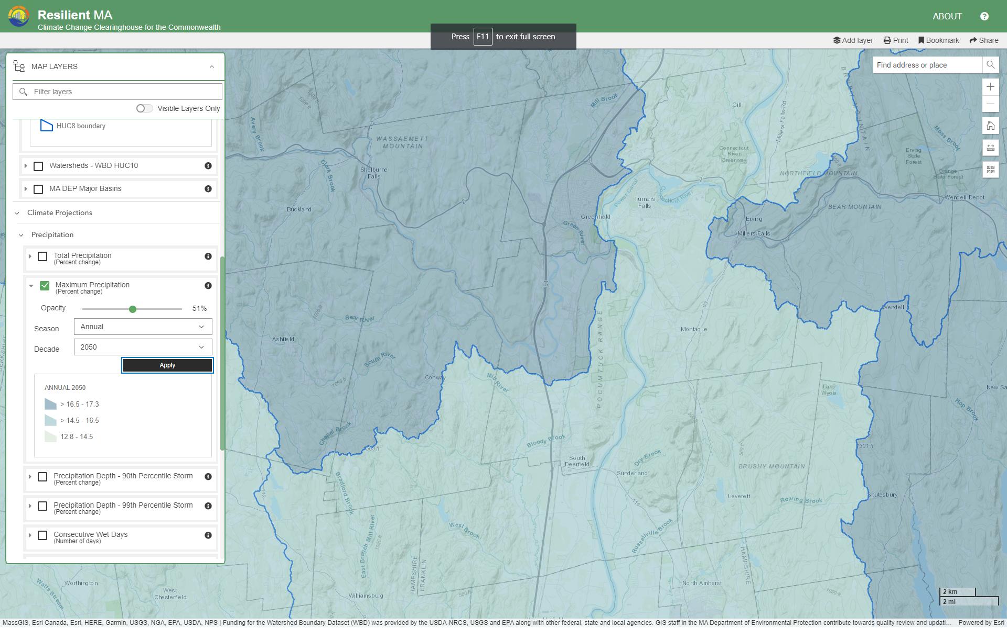
This map shows climate projections for the Deerfield area, illustrating that by 2050, annual rainfall will increase by 14-17 inches, with the greater amounts west of the Deerfield River.
Source: Resilient MA
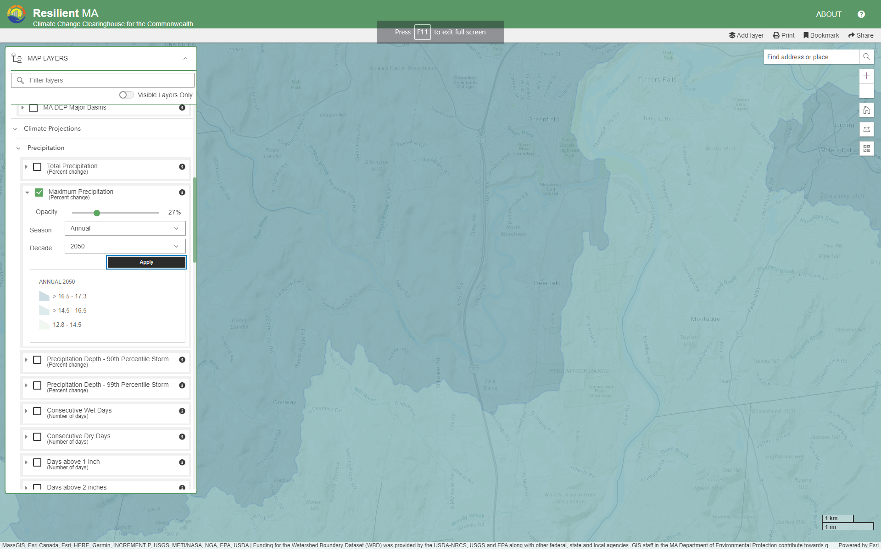
This map shows climate projections for the Deerfield area, illustrating that by 2050, maximum precipitation will increase by 14-17%, with the greater amounts west of the Deerfield River.
Source: Resilient MA
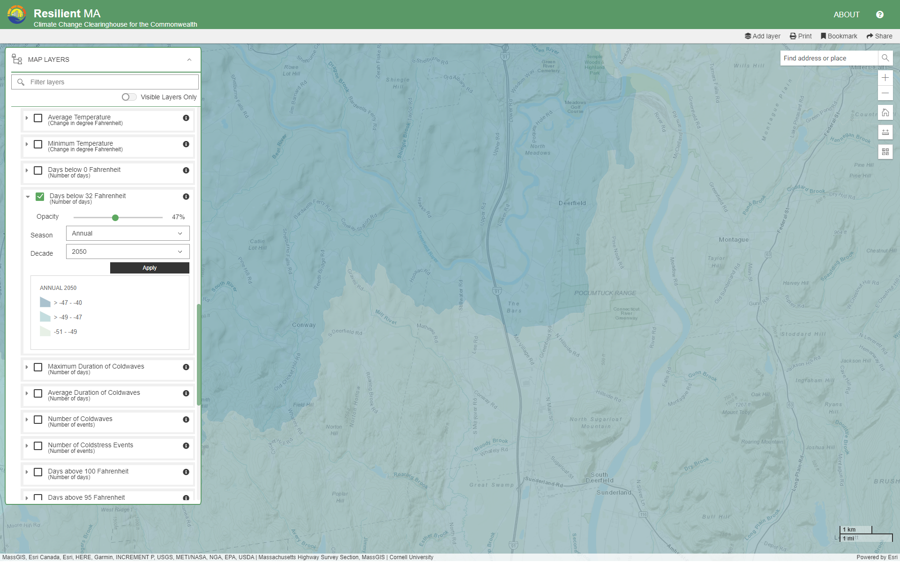
This map shows Days Below 32 degrees F for the Deerfield area, illustrating that by 2050, these days will decrease by 40-49 days, with the greater decrease east of the Deerfield River.
Source: Resilient MA
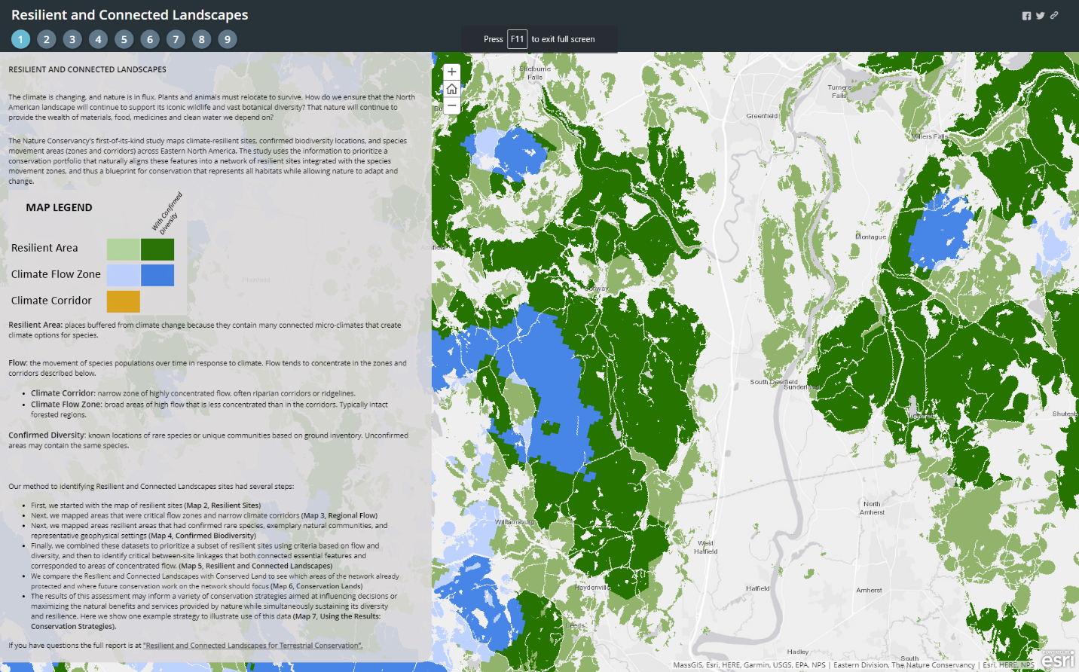
Source: The Nature Conservancy
This map shows important areas in Deerfield for climate resiliency and species diversity:
Resilient Area: places buffered from climate change because they contain many connected micro-climates that create climate options for species.
Flow: the movement of species populations over time in response to climate. Flow tends to concentrate in the zones and corridors described below.
- Climate Corridor: narrow zone of highly concentrated flow, often riparian corridors or ridgelines.
- Climate Flow Zone: broad areas of high flow that is less concentrated than in the corridors. Typically intact forested regions.
Confirmed Diversity: known locations of rare species or unique communities based on ground inventory. Unconfirmed areas may contain the same species.

3f) Climate Projections for the Connecticut River Basin in Massachusetts
The Northeast Climate Science Center at UMass has prepared a set of detailed climate change projections, which are specific to each watershed area in Massachusetts. The Town of Deerfield is included within the Connecticut River Basin.
Figure 3. Municipalities Within the Connecticut River Basin
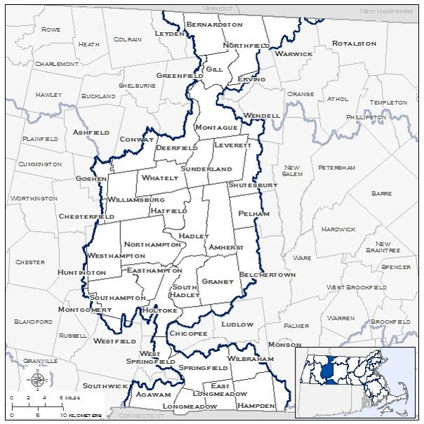
Key overall findings of this work include:
- Annual air temperatures in the Northeast have been warming at an average rate of 0.5°F per decade since 1970.
- Average annual temperatures for the CT River Basin will increase from baseline of 47°F by 3-7° by mid-century and by 4-11° by end of century

Findings specific to the Connecticut River Basin are summarized here:

Figure 4. Projected Temperature Changes in Connecticut River Basin
Connecticut Basin |  | Observed Baseline  1971-2000 (°F) | Projected Change in 2030s (°F) |  |  | Mid-Century  Projected Change in 2050s (°F) |  |  | Projected Change in 2070s (°F) |  |  | End of Century  Projected Change in 2090s (°F)
Average  Temperature | Annual | 46.98 | +2.18 | to | +4.46 | +3.00 | to | +6.43 | +3.57 | to | +9.00 | +4.04 | to | +10.94
Average  Temperature | Winter | 25.01 | +2.36 | to | +5.37 | +3.02 | to | +7.99 | +3.95 | to | +9.54 | +4.18 | to | +10.83
Average  Temperature | Spring | 45.35 | +1.51 | to | +3.30 | +2.26 | to | +5.21 | +2.76 | to | +7.23 | +3.11 | to | +8.81
Average  Temperature | Summer | 67.93 | +2.19 | to | +4.54 | +3.05 | to | +7.24 | +3.44 | to | +10.52 | +3.91 | to | +12.94
Average  Temperature | Fall | 49.24 | +2.27 | to | +5.23 | +3.81 | to | +6.81 | +3.75 | to | +9.57 | +4.21 | to | +11.69
Maximum Temperature | Annual | 58.45 | +2.03 | to | +4.24 | +2.65 | to | +6.56 | +3.18 | to | +9.13 | +3.63 | to | +11.03
Maximum Temperature | Winter | 35.23 | +1.96 | to | +4.66 | +2.61 | to | +7.11 | +3.19 | to | +8.53 | +3.43 | to | +9.63
Maximum Temperature | Spring | 57.16 | +1.38 | to | +3.23 | +2.13 | to | +5.16 | +2.66 | to | +7.53 | +3.17 | to | +8.99
Maximum Temperature | Summer | 80.18 | +1.89 | to | +4.67 | +2.75 | to | +7.45 | +3.25 | to | +10.93 | +3.76 | to | +13.41
Maximum Temperature | Fall | 60.8 | +2.47 | to | +5.04 | +3.65 | to | +7.16 | +3.54 | to | +9.91 | +4.21 | to | +12.20
Minimum Temperature | Annual | 35.51 | +2.38 | to | +4.81 | +3.35 | to | +6.64 | +3.93 | to | +8.89 | +4.37 | to | +10.89
Minimum Temperature | Winter | 14.8 | +2.63 | to | +6.03 | +3.56 | to | +8.76 | +4.51 | to | +10.54 | +4.94 | to | +11.83
Minimum Temperature | Spring | 33.53 | +1.62 | to | +3.63 | +2.38 | to | +5.64 | +2.96 | to | +7.07 | +3.29 | to | +8.59
Minimum Temperature | Summer | 55.67 | +2.34 | to | +4.62 | +3.21 | to | +7.33 | +3.63 | to | +10.13 | +4.07 | to | +12.49
Minimum Temperature | Fall | 37.68 | +1.97 | to | +5.33 | +3.58 | to | +6.64 | +3.82 | to | +9.22 | +4.21 | to | +11.37

- The Connecticut River basin is expected to experience increased average temperatures throughout the 21st century. Maximum and minimum temperatures are also expected to increase throughout the end of the century. These increased temperature trends are expected for annual and seasonal projections.
- Seasonally, maximum summer and fall temperatures are expected to see the highest projected increase throughout the 21st century.
  - Summer mid-century increase of 2.8 °F to 7.5 °F (3-9% increase); end of century increase of 3.8 °F to 13.4 °F (5-17% increase).
  - Fall mid-century increase of 3.7°F to 7.2°F (6-12% increase); end of century increase by and 4.2 °F to 12.2 °F (7-20% increase).
- Seasonally, minimum winter and fall temperatures are expected to see increases throughout the 21st century.
  - Winter mid-century increase of 3.6 °F to 8.8 °F (24-59% increase); end of century increase by 4.9 °F to 11.8 °F (33-80% increase).
  - Fall mid-century of 3.6 °F to 6.6 °F (10-18% increase); end of century increase of 4.2°F to 11.4 °F (11-30% increase).

Figure 5. Projected Changes Hot Weather Days in Connecticut River Basin
Connecticut Basin |  | Observed Baseline  1971-2000 (Days) | Projected Change in 2030s (Days) |  |  | Mid-Century  Projected Change in 2050s (Days) |  |  | Projected Change in 2070s (Days) |  |  | End of Century  Projected Change in 2090s (Days)
Days with Maximum Temperature Over 90°F | Annual | 6.41 | +6.36 | to | +19.72 | +9.87 | to | +35.35 | +11.98 | to | +57.07 | +14.50 | to | +76.01
Days with Maximum Temperature Over 90°F | Winter | 0.00 | +0.00 | to | +0.00 | +0.00 | to | +0.00 | +0.00 | to | +0.00 | +0.00 | to | +0.00
Days with Maximum Temperature Over 90°F | Spring | 0.39 | +0.14 | to | +0.91 | +0.30 | to | +1.76 | +0.37 | to | +3.31 | +0.28 | to | +5.00
Days with Maximum Temperature Over 90°F | Summer | 5.73 | +5.53 | to | +16.97 | +8.31 | to | +29.50 | 10.37 | to | +46.30 | +12.47 | to | +60.30
Days with Maximum Temperature Over 90°F | Fall | 0.29 | +0.44 | to | +2.09 | +0.51 | to | +4.58 | +0.61 | to | +8.80 | +1.02 | to | +11.94
Days with Maximum Temperature Over 95°F | Annual | 0.46 | +1.74 | to | +7.34 | +2.77 | to | +16.31 | +3.55 | to | +32.96 | +4.56 | to | +49.67
Days with Maximum Temperature Over 95°F | Winter | 0.00 | +0.00 | to | +0.00 | +0.00 | to | +0.00 | +0.00 | to | +0.00 | +0.00 | to | +0.00
Days with Maximum Temperature Over 95°F | Spring | 0.00 | +0.00 | to | +0.26 | +0.02 | to | +0.49 | +0.04 | to | +1.03 | +0.03 | to | +1.93
Days with Maximum Temperature Over 95°F | Summer | 0.45 | +1.71 | to | +6.53 | +2.54 | to | +14.84 | +3.05 | to | +28.97 | +4.16 | to | +43.03
Days with Maximum Temperature Over 95°F | Fall | 0.01 | +0.06 | to | +0.63 | +0.09 | to | +1.19 | +0.13 | to | +3.23 | +0.20 | to | +4.87
Days with Maximum Temperature Over 100°F | Annual | 0.00 | +0.14 | to | +1.54 | +0.22 | to | +4.35 | +0.41 | to | +11.64 | +0.38 | to | +23.33
Days with Maximum Temperature Over 100°F | Winter | 0.00 | +0.00 | to | +0.00 | +0.00 | to | +0.00 | +0.00 | to | +0.00 | +0.00 | to | +0.00
Days with Maximum Temperature Over 100°F | Spring | 0.00 | +0.00 | to | +0.03 | +0.00 | to | +0.06 | +0.00 | to | +0.21 | +0.00 | to | +0.45
Days with Maximum Temperature Over 100°F | Summer | 0.00 | +0.13 | to | +1.45 | +0.20 | to | +4.17 | +0.36 | to | +10.72 | +0.33 | to | +21.46
Days with Maximum Temperature Over 100°F | Fall | 0.00 | +0.00 | to | +0.14 | +0.00 | to | +0.37 | +0.01 | to | +0.75 | +0.00 | to | +1.29

- Due to projected increases in average and maximum temperatures throughout the end of the century, the Connecticut River basin is also expected to experience an increase in very hot days.
  - Annually, the Connecticut River basin is expected to see days with daily maximum temperatures over 90 °F increase by 10 to 35 more days by mid-century, and 15 to 76 more days by the end of the century.
  - Seasonally, summer is expected to see an increase of 8 to 30 more days with daily maximums over 90 °F by mid-century.
  - By end of century, the Connecticut basin is expected to have 12 to 60 more days with daily maximums over 90 °F by mid-century.
Figure 6. Projected Changes in Cold Weather Days in Connecticut River Basin
Connecticut Basin |  | Observed Baseline  1971-2000 (Days) | Projected Change in 2030s (Days) |  |  |  | Mid-Century  Projected Change in 2050s (Days) |  |  |  | Projected Change in 2070s (Days) |  |  |  | End of Century  Projected Change in 2090s (Days)
Days with Minimum Temperature Below 0°F | Annual | 11.33 | -4.01 | to | -7.02 | -4.88 |  | to | -8.3 | -5.42 |  | to | -8.76 | -5.53 |  | to |  | -9.57
Days with Minimum Temperature Below 0°F | Winter | 11 | -3.84 | to | -6.82 | -4.67 |  | to | -7.96 | -5.11 |  | to | -8.52 | -5.33 |  | to |  | -9.1
Days with Minimum Temperature Below 0°F | Spring | 0.38 | -0.08 | to | -0.44 | -0.12 |  | to | -0.44 | -0.18 |  | to | -0.49 | -0.18 |  | to |  | -0.55
Days with Minimum Temperature Below 0°F | Summer | 0.00 | -0.00 | to | -0.00 | -0.00 |  | to | -0.00 | -0.00 |  | to | -0.00 | -0.00 |  | to |  | -0.00
Days with Minimum Temperature Below 0°F | Fall | 0.01 | -0.02 | to | -0.00 | -0.02 |  | to | -0.00 | -0.02 |  | to | -0.00 | -0.02 |  | to |  | -0.00
Days with Minimum Temperature Below 32°F | Annual | 158.63 | -10.58 | to | -28.13 | -18.57 |  | to | -37.28 | -22.18 |  | to | -50.76 | -22.88 |  | to |  | -59.79
Days with Minimum Temperature Below 32°F | Winter | 85.33 | -1.15 | to | -5.9 | -2.37 |  | to | -8.5 | -3.50 |  | to | -15.82 | -4.26 |  | to |  | -19.49
Days with Minimum Temperature Below 32°F | Spring | 41.52 | -3.47 | to | -9.56 | -6.03 |  | to | -13.97 | -6.70 |  | to | -17.87 | -8.82 |  | to |  | -19.42
Days with Minimum Temperature Below 32°F | Summer | 0.02 | -0.01 | to | -0.17 | -0.01 |  | to | -0.27 | -0.01 |  | to | -0.23 | -0.01 |  | to |  | -0.26
Days with Minimum Temperature Below 32°F | Fall | 31.7 | -4.87 | to | -12.57 | -9.60 |  | to | -15.50 | -8.89 |  | to | -19.96 | -9.36 |  | to | -22.29

- Due to projected increases in average and minimum temperatures throughout the end of the century, the Connecticut River basin is expected to experience a decrease in days with daily minimum temperatures below 32 °F and 0 °F.
- Seasonally, winter, spring and fall are expected to see the largest decreases in days with daily minimum temperatures below 32 °F.
  - Winter is expected to have 2 to 9 fewer days by mid-century, and 4 to 19 fewer by end of century.
  - Spring is expected to have 6 to 14 fewer days by mid-century, and 9 to 19 fewer by end of century.
  - Fall is expected to have 10 to 16 fewer days by mid-century, and 9 to 22 fewer days by end of century.

Figure 7. Projected Changes in Degree Days in Connecticut River Basin
Connecticut Basin |  | Observed Baseline  1971-2000 (Degree-Days) | Projected Change in 2030s (Degree-Days) |  |  | Mid-Century  Projected Change in 2050s (Degree-Days) |  |  | Projected Change in 2070s (Degree-Days) |  |  | End of Century  Projected Change in 2090s (Degree-Days)
Heating Degree-Days  (Base 65°F) | Annual | 7038.04 | -579.08 | to | -1220.89 | -807.65 | to | -1696.71 | -932.31 | to | -2213.81 | -1061.27 | to | -2563.22
Heating Degree-Days  (Base 65°F) | Winter | 3617.34 | -196.64 | to | -492.19 | -267.53 | to | -731.67 | -348.79 | to | -867.16 | -385.45 | to | -997.60
Heating Degree-Days  (Base 65°F) | Spring | 1827.32 | -122.30 | to | -279.16 | -188.81 | to | -436.93 | -225.95 | to | -566.74 | -272.18 | to | -666.52
Heating Degree-Days  (Base 65°F) | Summer | 127 | -45.72 | to | -80.45 | -63.18 | to | -101.77 | -66.76 | to | -116.60 | -72.74 | to | -119.29
Heating Degree-Days  (Base 65°F) | Fall | 1471.22 | -176.19 | to | -404.39 | -298.62 | to | -486.71 | -283.22 | to | -674.74 | -306.64 | to | -768.06
Cooling  Degree-Days  (Base 65°F) | Annual | 459.27 | +200.92 | to | +430.52 | +272.64 | to | +749.47 | +326.52 | to | +1142.40 | +379.72 | to | +1504.58
Cooling  Degree-Days  (Base 65°F) | Winter | nan | -0.39 | to | +2.36 | +0.05 | to | +6.58 | -0.14 | to | +3.38 | -0.29 | to | +7.15
Cooling  Degree-Days  (Base 65°F) | Spring | 20.23 | +10.02 | to | +28.89 | +17.52 | to | +55.39 | +21.11 | to | +92.67 | +20.81 | to | +121.55
Cooling  Degree-Days  (Base 65°F) | Summer | 396.24 | +162.41 | to | +335.42 | +204.13 | to | +564.51 | +235.28 | to | +853.52 | +270.64 | to | +1075.43
Cooling  Degree-Days  (Base 65°F) | Fall | 37.72 | +25.68 | to | +84.68 | +40.57 | to | +136.51 | +49.64 | to | +225.83 | +63.95 | to | +304.46
Growing Degree-Days  (Base 50°F) | Annual | 2348.43 | +392.37 | to | +801.41 | +536.06 | to | +1252.31 | +652.08 | to | +1894.77 | +739.11 | to | +2379.52
Growing Degree-Days  (Base 50°F) | Winter | 3.8 | -0.26 | to | +8.95 | +0.09 | to | +9.32 | +0.51 | to | +14.24 | +1.70 | to | +19.27
Growing Degree-Days  (Base 50°F) | Spring | 278.98 | +59.68 | to | +130.77 | +91.58 | to | +225.48 | +117.65 | to | +331.37 | +117.61 | to | +434.70
Growing Degree-Days  (Base 50°F) | Summer | 1649.87 | +201.11 | to | +416.74 | +279.05 | to | +664.79 | +315.32 | to | +966.48 | +358.57 | to | +1190.01
Growing Degree-Days  (Base 50°F) | Fall | 403.13 | +105.14 | to | +284.19 | +169.55 | to | +395.11 | +166.52 | to | +591.21 | +211.39 | to | +734.09
Note: Degree day is a measurement designed to quantify the demand for energy needed to heat or cool a building.
- Due to projected increases in average, maximum, and minimum temperatures throughout the end of the century, the Connecticut basin is expected to experience a decrease in heating degree-days, and increases in both cooling degree-days and growing (agricultural) degree-days.
- Seasonally, winter historically exhibits the highest number of heating degree-days and is expected to see the largest decrease of any season, but spring and fall are also expected to see significant change.
  - The winter season is expected to see a decrease of 7-20% (268-732 degree-days) by mid-century, and a decrease of 11-28% (385-998 degree-days) by the end of century.
  - The spring season is expected to decrease in heating degree-days by 10-24% (189-437 degree-days) by mid-century, and by 15-36% (272-667 degree-days) by the end of century.
  - The fall season is expected to have decreases in heating degree-days by 20-33% (299-487 degree-days) by mid-century, and by and 21-52% (307-768 degree-days) by the end of century.
- Conversely, due to projected increasing temperatures, summer cooling degree-days are expected to increase by 52-142% (204-565 degree-days) by mid-century, and by 68-271% (271-1075 degree-days) by end of century.
- Seasonally, summer historically exhibits the highest number of growing degree-days and is expected to see the largest decrease of any season, but the shoulder seasons of spring and fall are also expected to see an increase in growing degree-days.
  - The summer season is projected to increase by 17-40% (279-665 degree-days) by mid-century, and by 22-72% (359-1190 degree-days) by end of century.
  - Spring is expected to see an increase by 33-81% (92-225 degree-days) by mid-century and 42-156% (118-435 degree-days) by end of century.
  - Fall is expected to see an increase by 42-98% (170-395 degree-days) by mid-century and 52-182% (211-734 degree-days) by end of century.
Figure 8. Projected Change in High Precipitation Days in Connecticut River Basin
Connecticut Basin |  | Observed Baseline  1971-2000 (Days) | Projected Change in 2030s (Days) |  |  | Mid-Century  Projected Change in 2050s (Days) |  |  | Projected Change in 2070s (Days) |  |  | End of Century  Projected Change in 2090s (Days)
Days with Precipitation Over 1” | Annual | 6.5 | +0.05 | to | +2.22 | +0.52 | to | +3.15 | +0.80 | to | +2.82 | +0.67 | to | +4.35
Days with Precipitation Over 1” | Winter | 1.04 | -0.04 | to | +0.74 | +0.05 | to | +1.01 | +0.06 | to | +1.30 | +0.22 | to | +1.64
Days with Precipitation Over 1” | Spring | 1.56 | -0.08 | to | +0.62 | +0.08 | to | +0.81 | +0.17 | to | +1.20 | +0.21 | to | +1.62
Days with Precipitation Over 1” | Summer | 1.98 | -0.37 | to | +0.57 | -0.19 | to | +0.97 | -0.34 | to | +0.66 | -0.38 | to | +0.74
Days with Precipitation Over 1” | Fall | 1.89 | -0.28 | to | +0.70 | -0.17 | to | +0.82 | -0.27 | to | +1.00 | -0.40 | to | +1.17
Days with Precipitation Over 2” | Annual | 0.55 | -0.05 | to | +0.40 | -0.01 | to | +0.39 | +0.00 | to | +0.45 | +0.04 | to | +0.58
Days with Precipitation Over 2” | Winter | 0.03 | -0.02 | to | +0.05 | -0.02 | to | +0.07 | -0.01 | to | +0.08 | -0.01 | to | +0.09
Days with Precipitation Over 2” | Spring | 0.1 | -0.03 | to | +0.10 | -0.03 | to | +0.09 | -0.02 | to | +0.17 | +0.00 | to | +0.25
Days with Precipitation Over 2” | Summer | 0.26 | -0.06 | to | +0.16 | -0.07 | to | +0.17 | -0.06 | to | +0.17 | -0.09 | to | +0.19
Days with Precipitation Over 2” | Fall | 0.16 | -0.06 | to | +0.17 | -0.06 | to | +0.16 | -0.04 | to | +0.18 | -0.05 | to | +0.19
Days with Precipitation Over 4” | Annual | 0.00 | -0.03 | to | +0.03 | -0.02 | to | +0.03 | -0.01 | to | +0.05 | -0.01 | to | +0.05
Days with Precipitation Over 4” | Winter | 0.00 | +0.00 | to | +0.00 | +0.00 | to | +0.00 | +0.00 | to | +0.00 | +0.00 | to | +0.00
Days with Precipitation Over 4” | Spring | 0.00 | +0.00 | to | +0.00 | +0.00 | to | +0.00 | +0.00 | to | +0.00 | +0.00 | to | +0.00
Days with Precipitation Over 4” | Summer | 0.00 | -0.02 | to | +0.02 | -0.02 | to | +0.02 | -0.02 | to | +0.03 | -0.02 | to | +0.03
Days with Precipitation Over 4” | Fall | 0.00 | -0.02 | to | +0.03 | -0.01 | to | +0.03 | -0.01 | to | +0.04 | -0.01 | to | +0.04

- The projections for expected number of days receiving precipitation over one inch are variable for the Connecticut basin, fluctuating between loss and gain of days.
  - Seasonally, the winter season is generally expected to see the highest projected increase.
  - The winter season is expected to see an increase in days with precipitation over one inch of 0-1 days by mid-century, and of 0-2 days by the end of century.
  - The spring season is expected to see an increase in days with precipitation over one inch of 0-1 days by mid-century, and of 0-2 days by the end of century.

Figure 9. Projected Changes in Total Precipitation in Connecticut River Basin
Connecticut Basin |  | Observed Baseline  1971-2000 (Inches) | Projected Change in 2030s (Inches) |  |  | Mid-Century  Projected Change in 2050s (Inches) |  |  | Projected Change in 2070s (Inches) |  |  | End of Century  Projected Change in 2090s (Inches)
Total Precipitation | Annual | 46.39 | -0.40 | to | +4.99 | +1.25 | to | +6.22 | +1.95 | to | +7.26 | +1.68 | to | +8.30
Total Precipitation | Winter | 10.34 | -0.39 | to | +2.08 | +0.07 | to | +2.59 | +0.30 | to | +3.03 | +0.73 | to | +3.87
Total Precipitation | Spring | 12.12 | -0.05 | to | +2.09 | +0.32 | to | +2.13 | +0.57 | to | +2.80 | +0.45 | to | +2.87
Total Precipitation | Summer | 11.98 | -0.37 | to | +1.76 | -0.17 | to | +2.13 | -0.34 | to | +1.85 | -1.03 | to | +1.90
Total Precipitation | Fall | 11.94 | -1.20 | to | +1.48 | -1.26 | to | +1.65 | -1.50 | to | +1.78 | -1.73 | to | +1.49

- Similar to projections for number of days receiving precipitation over a specified threshold, seasonal projections for total precipitation are also variable for the Connecticut River basin.
  - The winter season is expected to experience the greatest change with an increase of 1-25% by mid-century, and of 7-37% by end of century.
  - Projections for the summer and fall seasons are more variable and could see either a drop or increase in total precipitation throughout the 21st century.
    - The summer season projections for the Connecticut River basin could see a decrease of 0.2 to an increase of 2.1 inches by mid-century (decrease of 1% to increase of 18%), and a decrease of 1.0 to an increase of 1.9 inches by the end of the century (decrease of 9% to increase of 16%).
    - The fall season projections for the Connecticut River basin could see a decrease of 1.3 to an increase of 1.7 inches by mid-century (decrease of 11% to increase of 14% and a decrease of 1.7 to an increase of 1.5 inches by the end of the century (decrease of 14% to increase of 12%).
Figure 10. Projected Changes in Dry Days in Connecticut River Basin
Connecticut Basin |  | Observed Baseline  1971-2000 (Days) | Projected Change in 2030s (Days) |  |  | Mid-Century  Projected Change in 2050s (Days) |  |  | Projected Change in 2070s (Days) |  |  | End of Century  Projected Change in 2090s (Days)
Consecutive Dry Days | Annual | 16.41 | -0.18 | to | +1.34 | -0.42 | to | +1.75 | -0.73 | to | +2.26 | -0.35 | to | +2.44
Consecutive Dry Days | Winter | 11.4 | -0.77 | to | +1.14 | -0.57 | to | +1.30 | -0.80 | to | +1.18 | -1.21 | to | +1.47
Consecutive Dry Days | Spring | 11.95 | -1.05 | to | +0.50 | -0.91 | to | +1.05 | -1.24 | to | +1.13 | -1.24 | to | +0.76
Consecutive Dry Days | Summer | 11.57 | -0.70 | to | +1.46 | -0.61 | to | +1.07 | -0.91 | to | +1.61 | -1.37 | to | +1.87
Consecutive Dry Days | Fall | 12.03 | -0.12 | to | +1.72 | -0.21 | to | +2.35 | -0.61 | to | +2.61 | -0.13 | to | +2.78

- Annual and seasonal projections for consecutive dry days, or for a given period, the largest number of consecutive days with precipitation less than 1 mm (~0.04 inches), are variable throughout the 21st century.
  - Seasonally, the fall and summer seasons are expected to continue to experience the highest number of consecutive dry days.
  - The fall season is expected to experience an increase of 0-3 days in consecutive dry days by the end of the century.

4. CLIMATE IMpacts to Deerfield
The Town of Deerfield has completed several previous projects that have helped with preparations for this Municipal Vulnerability Preparedness project. This work is summarized below.
Deerfield Multi-Hazard Mitigation Plan
In 2014, the Town completed a Multi-Hazard Mitigation (MHM) Plan, coordinated by the Deerfield Local Multi-hazard Mitigation Planning Committee.
This MHM Plan identified the key natural hazards which are the most important concerns in Deerfield:
- Floods
- Severe winter storms
- Hurricanes and tropical storms
- Tornados, microbursts, thunderstorms
- Wildfires and brushfires
- Dam failures
- Earthquakes
- Landslides
- Ice jams

Major Flood Years and Disasters in Franklin County
Since 1993, the most significant flood years in Franklin County have included:
- 2011- 8 events - $22.3m in property damages, including Tropical Storm Irene
- 2005 – 5 events - $11.4 m in property damage, including Tropical Storm Tammy
- 1996 – 11 events – $1.8m in damages

Recent Storm Events and Damages
July, 2023 Storms
A series of three severe rainstorms over the month of July, 2023 caused severe damage to roads and infrastructure, and floodwaters damaged crops. The total reported damage from these storms in Deerfield was $4,706,000. Other nearby towns also suffered damages, but Deerfield had the highest total in western Massachusetts.
July 10, 2023
Heavy rainfall pushed the Deerfield River over flood stage, causing major crop damage in farmlands, inundating the north end of town and causing stormwater to back up across Greenfield Road in the Wapping Road area.
July 16, 2023
Torrential rains caused extensive flooding along Bloody Brook, and roadways and infrastructure failed throughout north Deerfield. Asphalt was severely damaged in many areas, including Stillwater Road, River Road and Pine Nook Road. Access to Conway was cut off along Route 116. Significant washouts occurred on dirt roads throughout town.
July 21, 2023
Before July 16 damage could be fixed, the most severe storm hit, washing away partially completed repairs. The storm dropped 8 inches of rain in 53 minutes! Huge washouts occurred on Hawks Road, Hoosac Road, Lower Road, Matthews Road, McClelland Farm Road, Pine Nook Road, River Road, Stillwater Road and elsewhere.

Damages to Hoosac Road from July, 2023 storm

Damages to Lower Road from July, 2023 storm

Matthews Road, July 22, 2023 Storm

Damage to Stillwater Road, July, 2023
December, 2023 Storm event
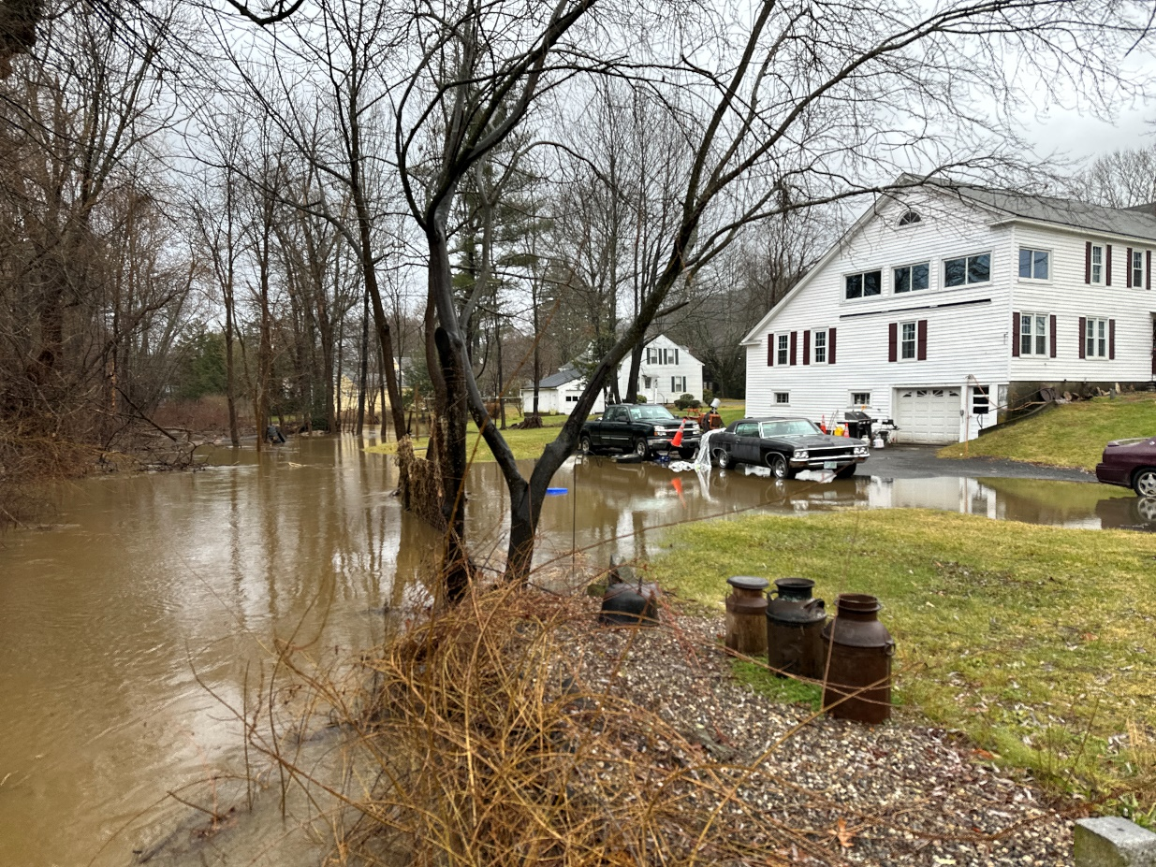
Flood backup at Pleasant St.
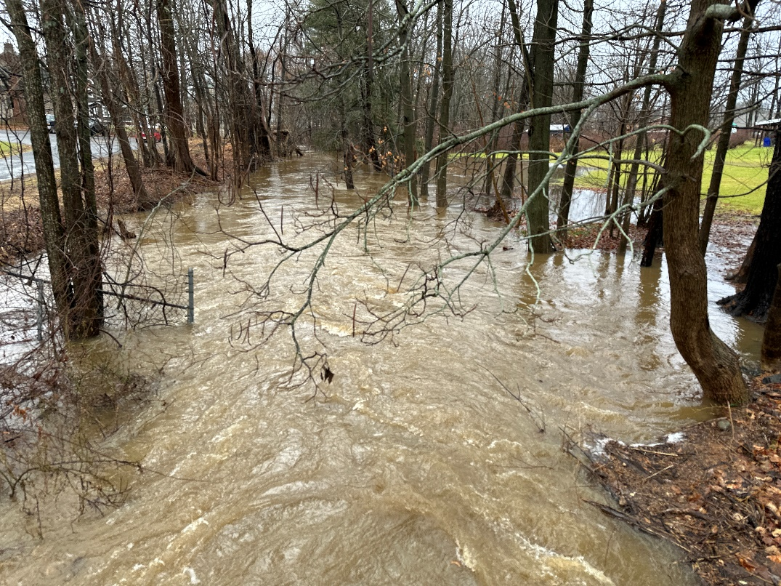
Pleasant St.
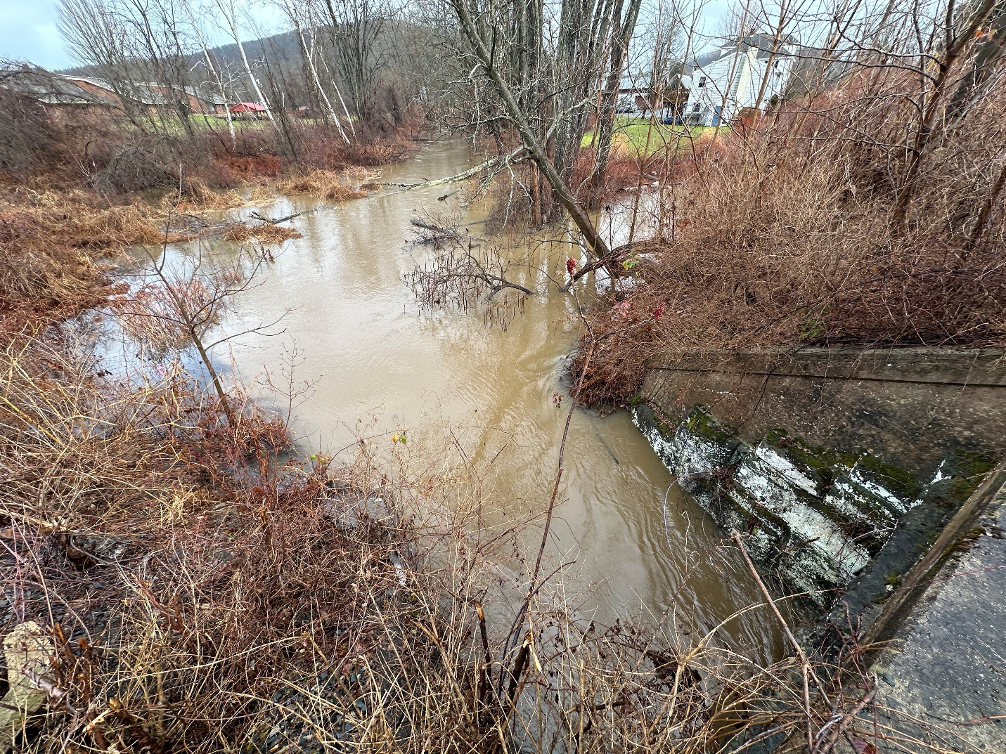
Flooding at railroad culvert in South Deerfield Center

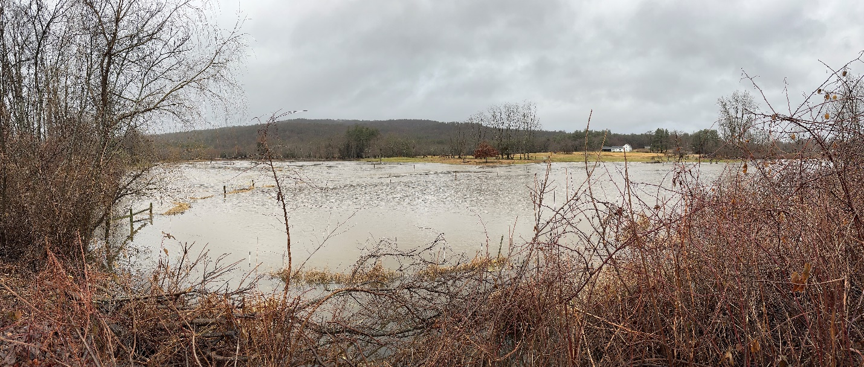
Flooding on Mill River near South Mill River Road

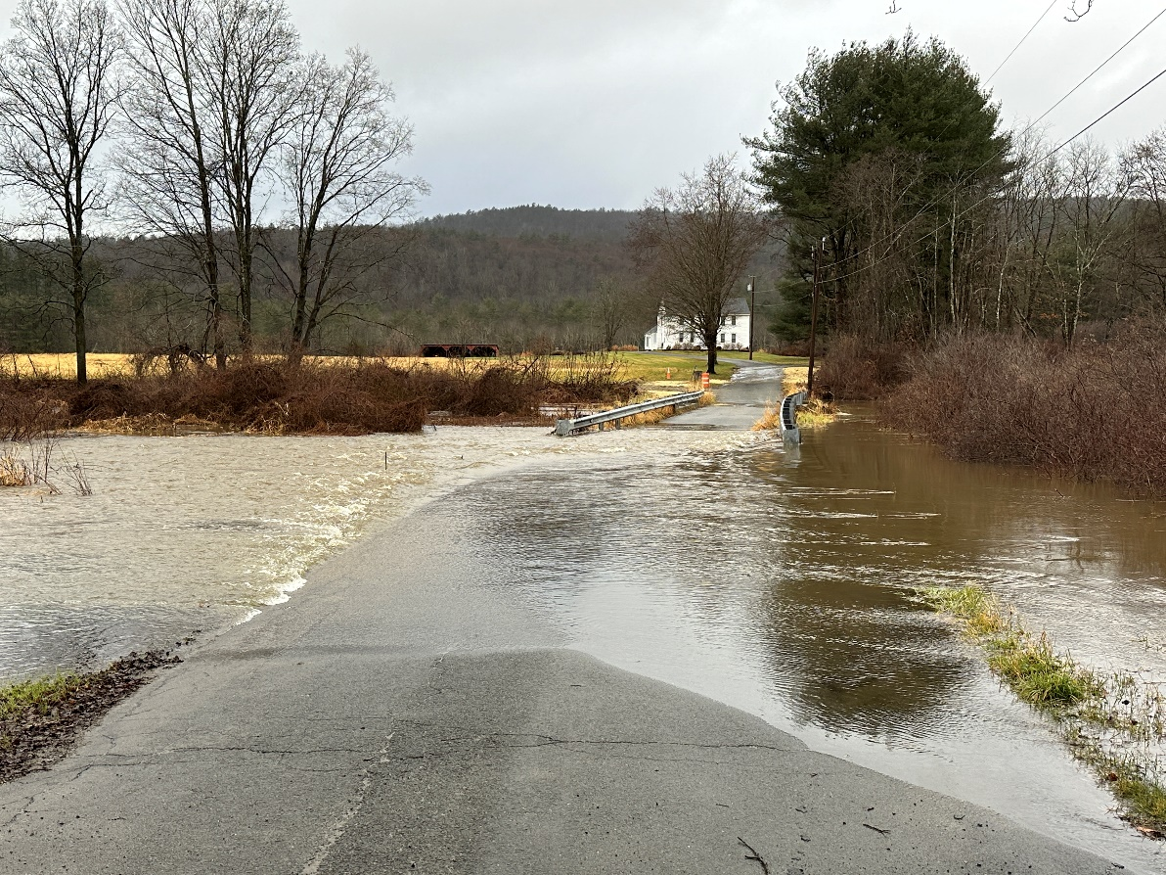
Flooding on Mill River near South Mill River Road

Flooding in Deerfield from Tropical Storm Irene

Presidential Disaster Declarations
Between the years 1993 and 2013, there have been twelve Presidential Disaster Declarations in Franklin County, shown below with the amount of federal aid to Franklin County:
- March 1993 – Blizzard, record snowfall - $1.2 million in federal aid
- January 1996 – Blizzard - $16.1 million in federal aid
- March 2001 – Snowstorm - $21 million in federal aid
- February 2003 – Snowstorm - $28 million in federal aid
- December 2003 – Snowstorm - $35.6 million in federal aid
- January 2005 – Snowstorm - $ 49.9 million in federal aid
- December 2008 – Winter storm - $66. million in federal aid
- December 2008 – Severe storm & flood - $ 32 million in federal aid
- January 2011 – Winter storm - $1 million in federal aid
- August 2011 – Tropical Storm Irene - $26.6 million in federal aid
- October 2011 –Severe winter storm - $71.9 million in federal aid
- February 2013 – Winter storm and flood - $16.4 million in federal aid
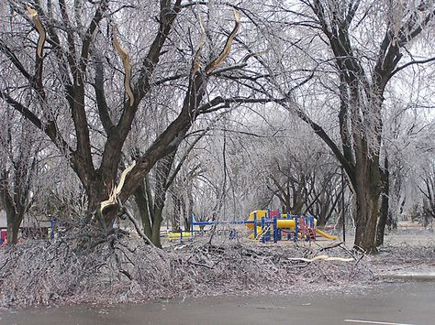
Winter storm damages
Damages to State Route 2 in Franklin County after Tropical Storm Irene
Impacts from Tropical Storm Irene
On August 28, 2011, Tropical Storm Irene, a weakened hurricane, crossed through New England, dumping 10-15” of rain on southern Vermont and western Massachusetts. In the resulting flooding, the Deerfield River crested at 23.7’, the highest recorded flow since 1955. Over 700,000 customers lost power in Massachusetts alone, and there was one flooding fatality on the Deerfield River.

Flooding spread across roads and farms along the Deerfield River and in the Old Deerfield area, impacting many properties, including:
- Deerfield Academy
- Historic Deerfield
- Bement School
- Routes 5/10
- Stillwater Bridge
- I-91 Bridge
- Mill Village Road
- Multiple farms

Overall, there were $23 million in damages in Franklin County alone due to this storm.

Repairing damages from Tropical Storm Irene at Stillwater in Deerfield

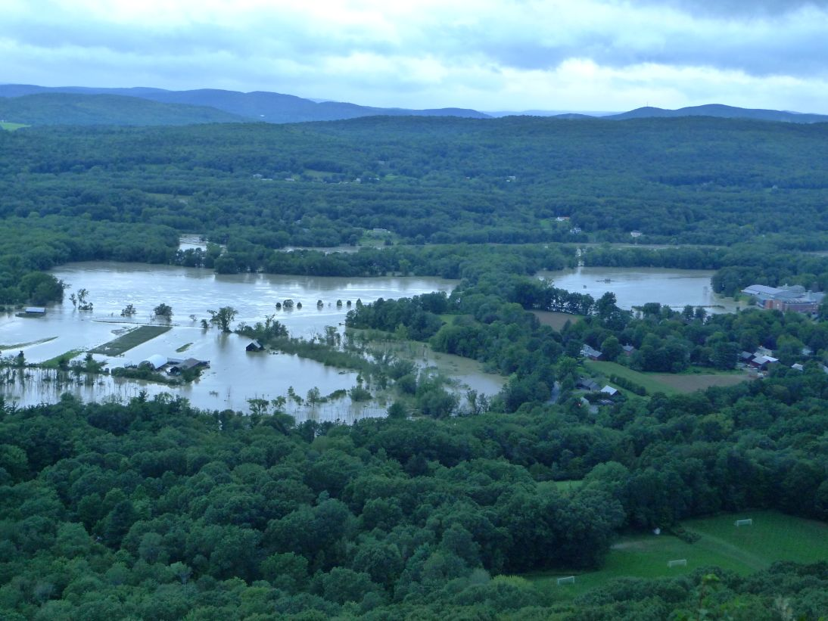
Flooding of Deerfield farmland from Tropical Storm Irene

Hurricanes to Make Landfall in New England
Since 1900, there have been eight hurricanes that have made landfall in New England, including hurricanes in the following years:
- 1904
- 1938
- 1954
- 1955
- 1960
- 1976
- 1985: Hurricane Gloria
- 1991: Hurricane Bob - $5.5 m in property & crop damage in Franklin County

Note: This list does not include tropical storms such as Tropical Storm Irene (2011), which also did major damage.
Flooded farmland in 2011’s Tropical Storm Irene

Tornados
There have been four recorded tornados in Franklin County in the last 15 years. They include:
- 7-3-97: Heath - $50k in property damages
- 7 -3-97: Charlemont - $50k in property damages
- 7-1-06: Wendell - $250k in property damages
- 2-25-17: Conway – an EF1 tornado severely damaged 12 homes and a church

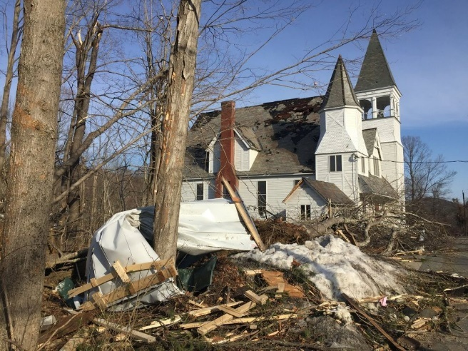
Tornado damage to Conway church
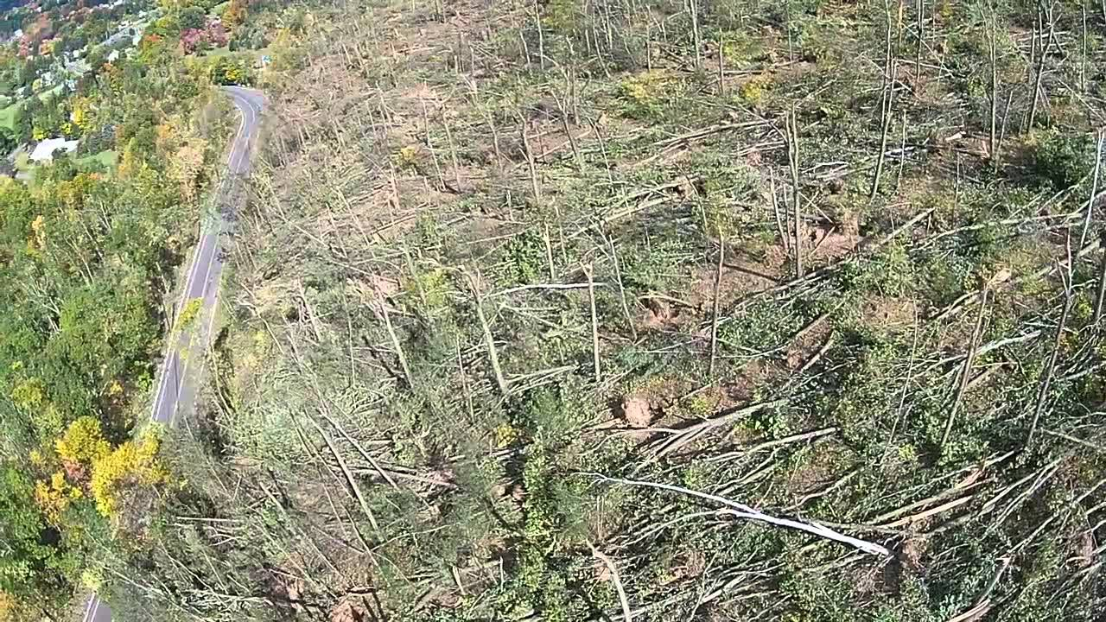
Microburst on Mount Tom

2011 Tornado in Westfield, Springfield, Monson: $24 m in damages

Other Hazards
The Deerfield Multi-Hazard Plan identified and quantified a series of other natural hazards to the town, including:
Thunderstorm, High Wind or Lightning Events:
- 11 events in or near Deerfield since 1993;
- $50k in damages in 2005 lightning storm.
Wildfires:
- Franklin County is at low risk, except for drought years;
- 26 brushfires in Deerfield from 2004-2010.
Earthquakes:
- Ten earthquakes in Northeast 1924-2007 of magnitude 4.7 or more, but none centered in Massachusetts;
- A fault line runs through Franklin County east of Deerfield.
Landslides:
- The Connecticut River Valley has a moderate landslide incidence rating;
- In March, 2011 Greenfield experienced a landslide;
- In November, 2011, Deerfield had a significant landslide in the Wapping Road area, which caused
Ice Jams:
- There are documented ice jam occurrences in the Deerfield River: 1947, 1957, 1959.
Dam Failures:
- There are six major dams of concern to Deerfield:
  - Somerset, Harriman, Sherman, Fife Brook and Bear Swamp Dams on the Deerfield River;
  - Moore Dam on the Connecticut River.
- Catastrophic failure of any of these dams would result in cascading dam failures;
- Harriman failure would reach Deerfield in 4 hours;
- Evacuations would be needed at Deerfield Academy and Bement School;
- Roads inundated would include Routes 5/10 and Old Main Street.

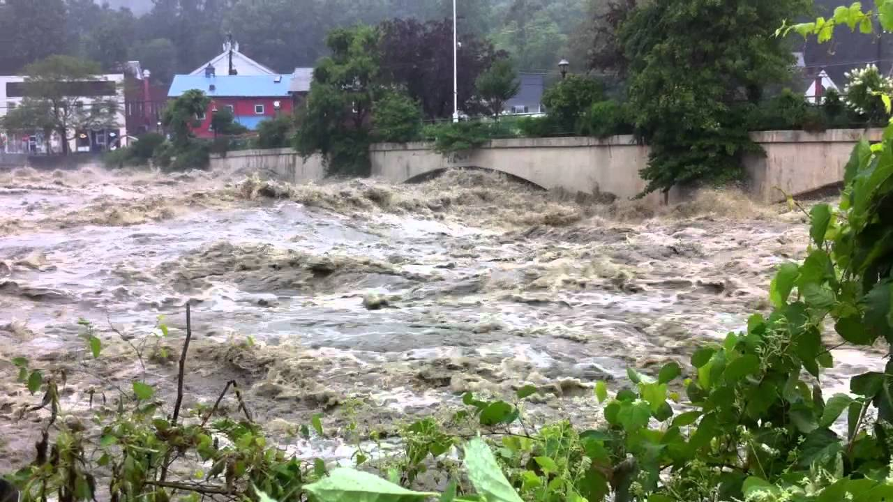
Flooding in Shelburne Falls, 2011
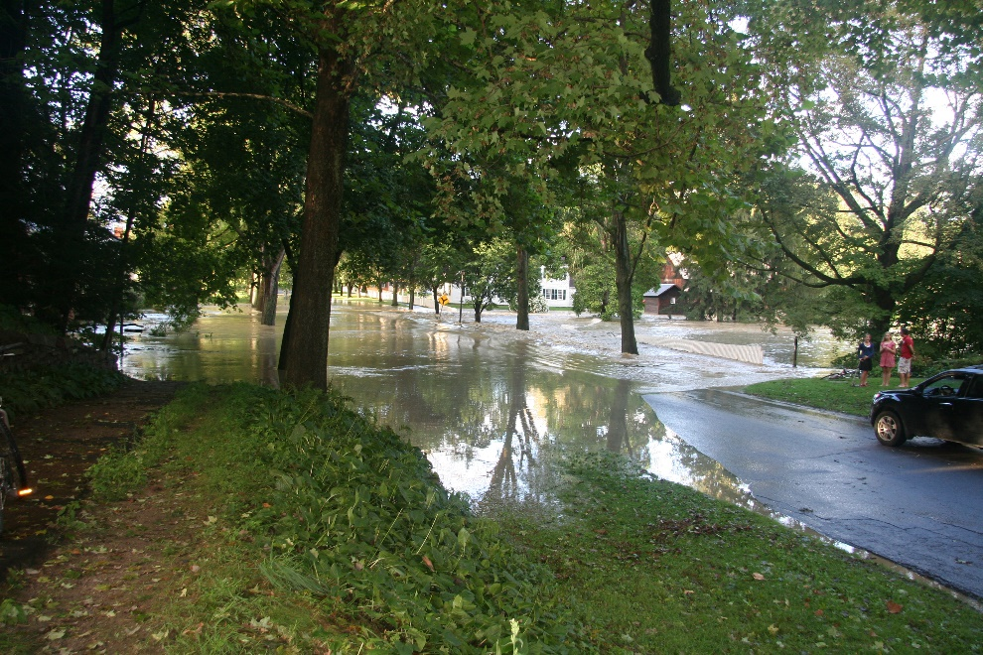
Flooding in Old Deerfield, 2011
Vulnerability Assessment
The Deerfield Multi-Hazard Plan assessed the town’s vulnerability to natural hazards and had these key findings:
- 24 dwellings are located in Deerfield’s flood hazard area
- 1358 elderly and low-income persons are exposed to multi-hazard events
- These significant structures are located in the floodplain: Historic Deerfield, Frontier Regional School, Old Deerfield Wastewater Treatment Plant, Deerfield Academy, Bement School
- Average annual property damages in Franklin County by storm type are:
  - Severe winter storms: $4.1m
  - Hurricanes: $1.3m
  - Tornados: $14k
  - Thunderstorms: $79k
  - Lightning: $34k
  - Floods: data not available

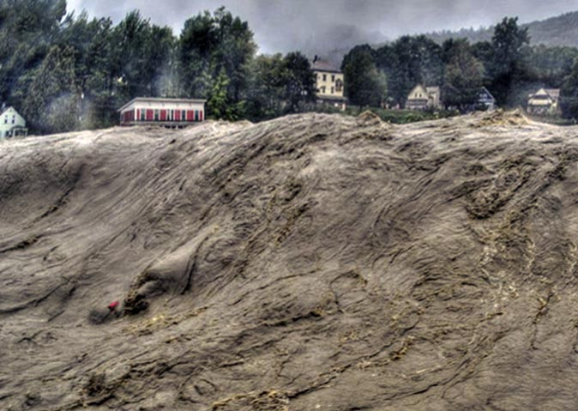
Flooding on Deerfield River in Shelburne Falls, MA, 2011

5. STORM REPAIR NEEDS
Deerfield’s road and drainage infrastructure, and its town budget, has been enormously impacted by the increased flooding and more severe storm events that are related to climate change. In particular, the town experienced very severe damages from the July, 2023 set of three storms and from Hurricane Irene in 2011. In the July 2023 storms alone, the town suffered $4.7 million in infrastructure damages.
After completing the storm damage repairs, there are still major infrastructure improvements needed in town. According to Deerfield’s Police Chief, John Paciorek, these needs are summarized below.
Critical Culverts That Still Need to Be Replaced
▪ Broughton’s Pond Road: Replace failing culvert
▪ Childs Cross Road: Remove undersized culvert and replace with larger one
▪ County Road: Replace nearly 40-footdeep collapsed culvert and roadway
▪ Cross Street: Remove undersized culvert and replace with larger one
▪ Kelleher Drive: Remove undersized culvert and replace with larger one
▪ Mill Village Road at Boynton Road: Remove undersized culvert and replace with larger one
▪ Pine Nook Road: Remove undersized culvert and install larger one able to handle the increased flow of water from more intense and frequent storms
▪ Plain Road (west): Replace failing culvert
▪ Steam Mill Road: Remove and install a new 30-inch culvert capable of handling hillside runoff near No. 51 and No. 52, reinforce washed-out embankment and repair sinkholes
▪ Whately Road (168): Install new culvert and two new catch basins as water turns into a river leading to roadway failure
▪ Numerous other culverts throughout town

Major Repairs Made Under Emergency Declaration
▪ Stage Road: Drop inlet failed and roadway shimmed
▪ Hillside Road: Collapsed culvert replaced with larger culvert
▪ Keets Road: Repaired extensive erosion/pavement damage, unblocked culvert at Keets Road and Greenfield Road
▪ Pine Nook Road: Repaired massive erosion, replaced catch basins, collapsed pipes (top to bottom)
▪ Pine Nook at Keith Cross Road: Removed and installed a 36” culvert in paved section just west of Keith Cross
▪ Lee Road (No. 87): Repaired collapsed secondary drainage pipe
▪ Keith Cross: Repaired
▪ Stillwater Road (Nos. 230 and 193): Repaved several areas of damage, removed and replaced catch basin, repaired erosion around culvert
▪ Graves Street: Removed undersized culvert and replaced with a larger pipe
▪ Conway Road: Repaired significant erosion and unplugged culvert
▪ Upper Road at Hawks Road: Repaired roadway which had collapsed (60’ X40’)
▪ Deerfield Water replaced broken pipes and washed-out area in several locations ▪ Old Main St
Lower Road

Data on Critical Culverts That Still Need to Be Replaced
The following data was collected by the Deerfield Town Planner to determine the viability of replacing culverts under the Massachusetts Division of Ecological Resources, Culvert Replacement Program.

▪ Broughton’s Pond Road: Replace failing culvert
Lat: 42.55409, Long: -72.60619
Impassability: 0.38
Connectivity Restoration Potential: NO DATA

▪ Childs Cross Road: Remove undersized culvert and replace with larger one
Lat: 42.52246, Long: -72.60833
Impassability: 0.19
Connectivity Restoration Potential: 0.29
Structural Risk: 0.90

▪ County Road: Replace nearly 40-footdeep collapsed culvert and roadway
Lat: 42.54124, Long: -72.59892
Impassability: 0.69
Connectivity Restoration Potential: 0.29

▪ Cross Street: Remove undersized culvert and replace with larger one
Unmapped

▪ Kelleher Drive: Remove undersized culvert and replace with larger one
NEED MORE DETAILS - May be in a BioMap rare species and/or NHESP ecoregion

▪ Mill Village Road at Boynton Road: Remove undersized culvert and replace with larger one
Unmapped

▪ Pine Nook Road: Remove undersized culvert and install larger one able to handle the increased flow of water from more intense and frequent storms
NEED MORE DETAILS - may be in a BioMap Forest/Wetland Core habitat and rare species

▪ Plain Road (west): Replace failing culvert
NEED MORE DETAILS - may be in a BioMap rare species area

▪ Steam Mill Road: Remove and install a new 30-inch culvert capable of handling hillside runoff near No. 51 and No. 52, reinforce washed-out embankment and repair sinkholes
Unmapped

▪ Whately Road (168): Install new culvert and two new catch basins as water turns into a river leading to roadway failure
NEED MORE DETAILS - possibly unmapped. May be in a BioMap rare species and/or NHESP ecoregion

FRCOG Deerfield Drainage Data
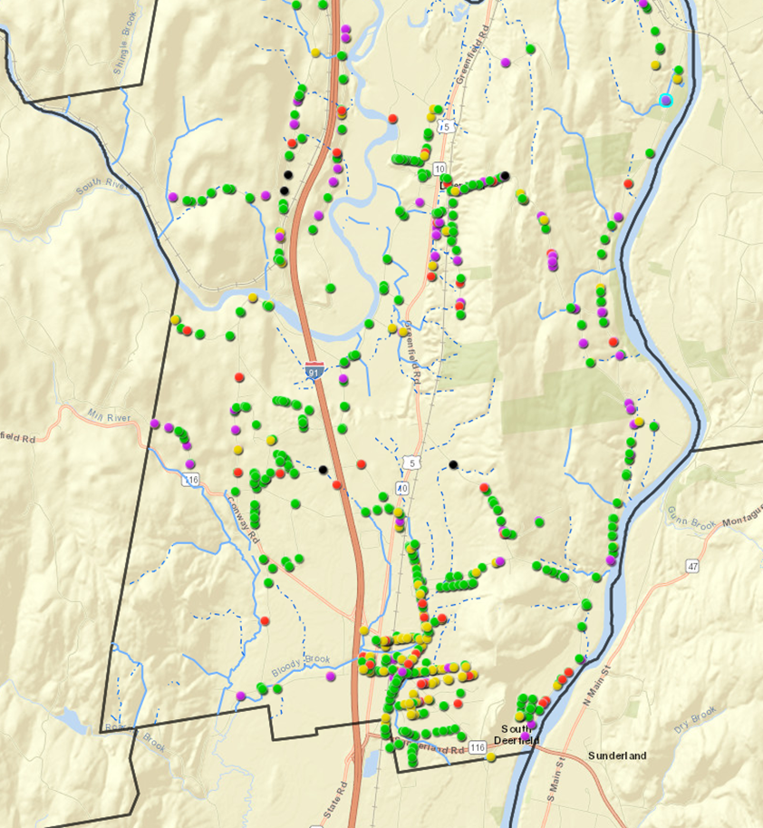
Legend: Purple=Critical; Red=Poor; Yellow=Fair; Green=Good; Blue=Dry Hydrant

Source: Franklin Regional Council of Governments

North American Stream Crossing Data
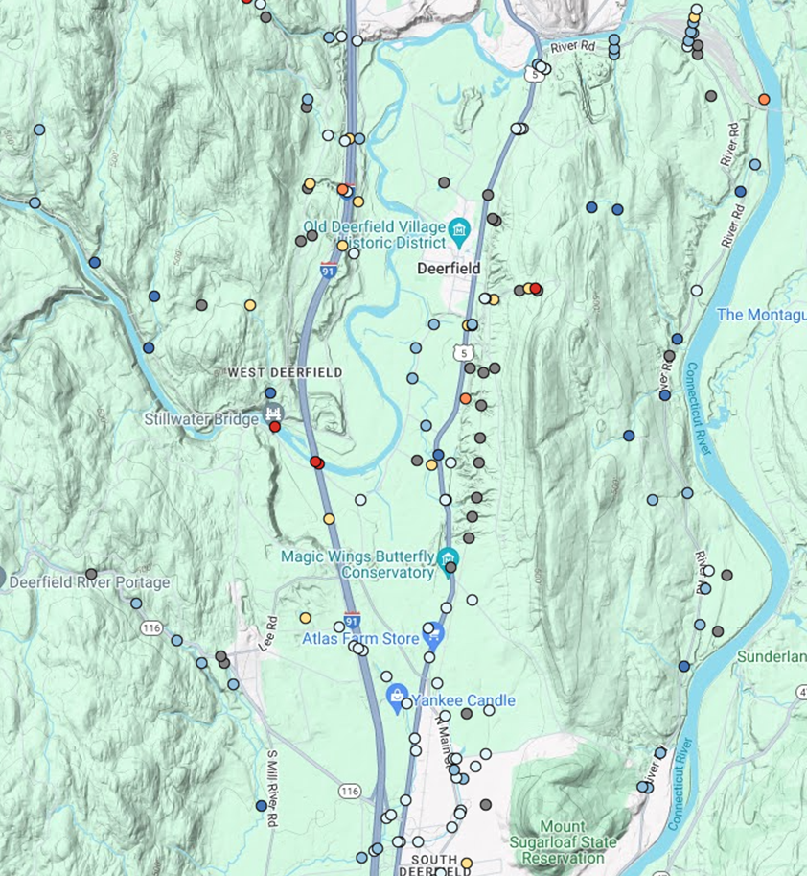

Legend:
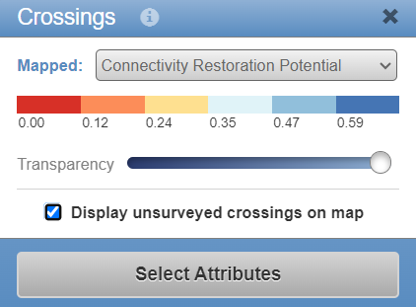
Source: North Atlantic Aquatic Connectivity Collaborative (NAAC) stream crossings database
This map shows Connectivity Restoration Potential which is a key criteria for DER Culvert grants.

FRCOG Culvert Study: Assessment Results
The Franklin Regional Council of Governments completed a “Town of Deerfield Culvert Assessment in August, 2021. The key findings of this report are shown below.
As noted above, 879 culverts and drainage structures were assessed on Town-maintained roads. Below is a quick summary of the results from the culvert inventory. This information provides an idea of the general state of the stormwater drainage infrastructure in town for both maintenance and budgeting purposes.
Fifty-seven percent (508) of the structures assessed are drop inlets or catch basins, of which:
- 36 are in Critical condition and need immediate maintenance or repair; and
- 33 are in Poor condition and will require maintenance or repair soon.
- Many of these structures just need to be cleaned out in order to improve their assessment rating.
There are a total of 76 structures associated with stream crossings, of which:
- 11 are in Critical condition and;
- 5 are in Poor condition.
- The majority of these structures require repair to their headwalls and wingwalls to ensure that they remain functional.
- Replacement of these culverts will require that they be brought up to current stream crossings standards, which can greatly increase their size (and cost), but will ensure that they be more resilient to future storm events.
There are a total of 91 structures that are larger than 36 inches in diameter.
- 6 are in Critical condition and; o 9 are in Poor condition.
- The majority of these structures require repair to their headwalls and wingwalls to ensure that they remain functional.
Top Problem Culverts Identified
The following culverts have been identified as those that have major issues and need immediate attention.
• Wapping Road – this road was assessed in June, prior to the heavy rainfall of July. At the time, there were multiple culverts that were blocked with sediment and needed to be cleaned out. As the Town is aware, this section has repeated flooding issues due to the low-lying nature of the land and the large amount of water that is draining from the adjoining hills. This causes flooding on both Wapping Road and Route 5/10.
• Childs Cross Road (culvert #180i) – this culvert is a 48 inch, open bottom stream crossing. The headwall and wingwalls have stones that have fallen out or are loose. The left wingwall, in particular, is in danger of failure.
• Upper Road (culvert # 302i and 302o) – this culvert is a drop inlet on one side with a 18 inch round pipe outlet. The invert of the pipe is almost completely rusted out and there is a large amount of scour under the outlet, destabilizing the bank around the outlet and roadside.
• Lower Road (culvert #249i) – this culvert is a 36 inch plastic pipe at a stream crossing. The headwall is slumping and at danger of failing. It also has large cracks that are greater than ¼ inch. The wingwall has loose, missing stones.
• River Road (culvert #81i and 81o) – this culvert is a 36 inch road pipe. The concrete headwalls on both the inlet and outlet are severely crumbling, with exposed rebar and cracks that are larger than ¼ inch. It is a stream crossing.
• Stillwater Road (culvert #230i and 230o) – this culvert is a drop inlet on one side with a 24 inch metal pipe outlet. The concrete cover on the inlet is missing and results in a large, dangerous hole at the roadside. The interior concrete blocks of the drop inlet are loose and missing. The outlet’s headwall also has loose and missing blocks.
• River Road (culvert #25i and 25o) – this culvert is a drop inlet on one side with a 24 inch metal pipe outlet. The cover on the inlet is missing and results in a large, dangerous hole at the roadside. The interior concrete blocks of the drop inlet are loose and missing. The outlet’s headwall has a concrete portion that is crumbling and the stone portion is very loose with missing stones. The invert of the pipe is rusted out for almost the entire length.
• Stage Road (culvert #376i) – this culvert is a drop inlet with erosion at the roadside causing a minor sinkhole. It appears that the Town is aware of this issue and is about to conduct repair work.

Priority Culvert Replacements for Town

Deerfield’s Town Planner prioritized the following culverts for replacement:

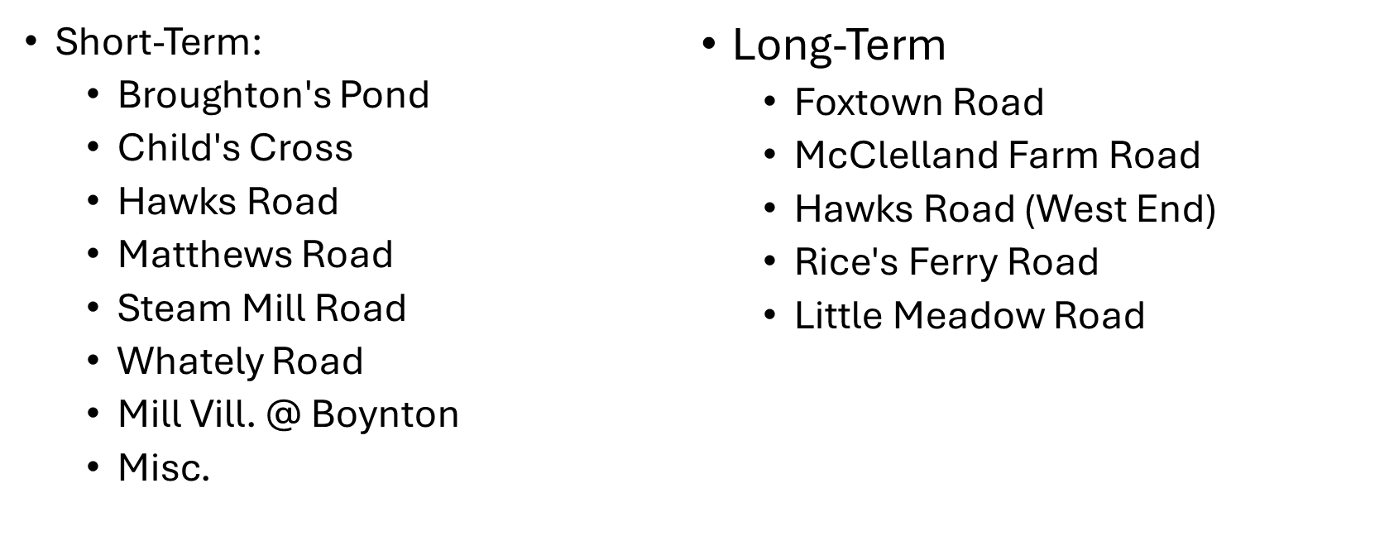

Recommended Approaches to Deerfield Culvert Replacements

Deerfield should consider a multi-faceted approach to culvert replacements, including:

- Continue applying for MVP grants for eligible culvert replacements;

- Consider working with DOT / railroads on addressing deficient downstream culverts;

- Keep DER Culvert Replacement grant program in mind when culverts located on west side of Town need replacement (this is where cold water fisheries are);

- See if there is room in scope of 604B project to review potential aquatic life passage on Ridge that would make culverts over streams draining into Connecticut River more competitive for DER Culvert Replacement grants.

6. PREVIOUS WORK: TOWN and REGIONAL CLIMATE AND HAZARD PLANNING

Deerfield Mitigation Work Completed To Date
The Town of Deerfield has completed several recent projects to mitigate the impacts of flooding and severe weather events, including:
- Mill Village Road restoration, 2009-10: total cost of $800,000
- Old Deerfield Wastewater Plant, 2006: total cost of $926,000
- Open bottom culvert, 2011-12: total cost of $120,000

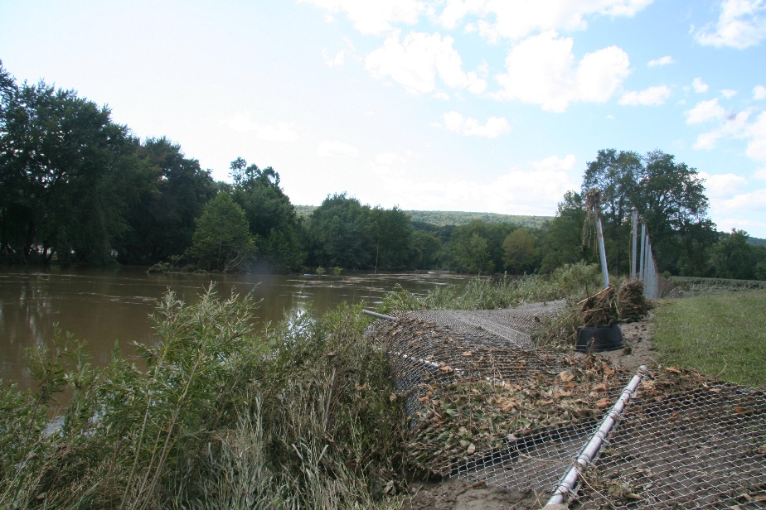
Flood damages at Old Deerfield wastewater treatment plant, 2011
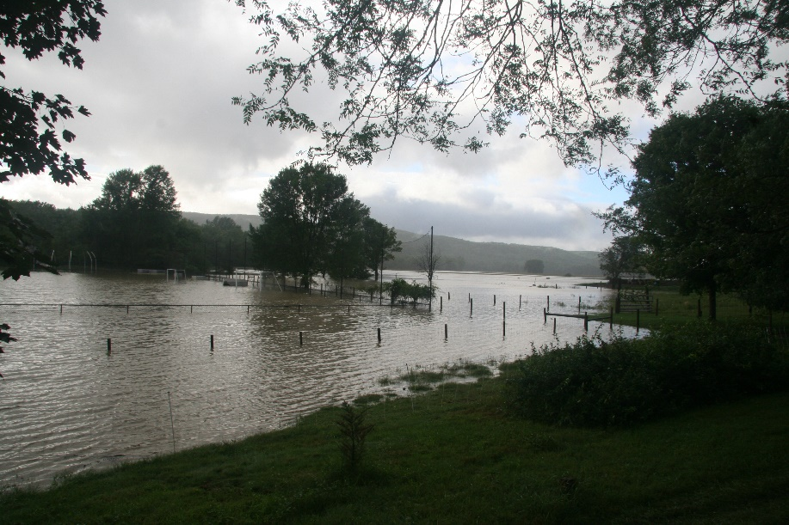
Flooding near Old Deerfield, 2011

River Smart Communities Recommendations
The Town of Deerfield participated in a state grant funded project, titled “River Smart Communities”. The final report for this project included the following recommendations:
- Develop fluvial hazard assessments to map risk of erosion or deposition
- Upgrade vulnerable stream crossings to reduce future damage
- Mitigate flood hazards through planning and land use
- Move threatened buildings and infrastructure
- Restore floodplains and riparian buffers
- Floodplain zoning

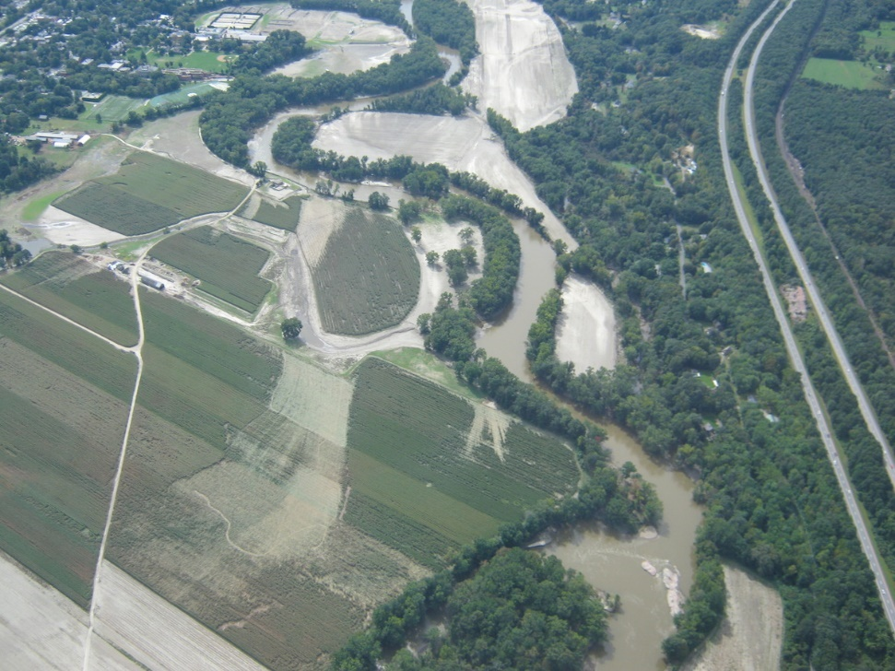
Aerial photo of Deerfield River flooding, Deerfield, MA, 2011

Pioneer Valley Climate Action Plan
The Pioneer Valley Planning Commission completed a regional plan, titled the “Pioneer Valley Climate Action Plan” in 2016, which included a number of recommendations that are relevant to the Town of Deerfield.
The PVPC plan recommends Municipal Strategies in three broad categories:
- Mitigation strategies: to reduce greenhouse gas emissions
- Adaptation strategies: to prepare for climate change impacts
- Energy Conservation & Clean Energy strategies: to achieve greater energy efficiency
Municipal Mitigation Strategies - These are recommended municipal strategies to reduce carbon emissions:
- Zoning for compact development, solar access
- Municipal Climate Action policy statements
- Green Communities designation: energy efficiency and development of renewables
- Reduce methane emissions from landfills
- Fuel efficient municipal vehicle fleets
- LED traffic signals and lights

Adaptation Strategies - These are recommended municipal strategies to prepare for climate change impacts:
- Replace under-performing culverts and bridges
- Formalize emergency water supply interconnections
- Prepare water supply system for extreme droughts including repairing leaks and installing water efficient fixtures
- Update FEMA flood maps
- Storm-proof critical infrastructure: energy, electrical, water, wastewater, roads, dams, flood dikes
- Assist populations vulnerable to severe weather events
- Conduct dam inspection, removal and repair
- Move powerlines underground
- Establish extreme weather warning system

Energy and Conservation Strategies - These are recommended municipal strategies to achieve greater energy efficiency:
- Streamline solar and wind zoning
- Participate in Solarize Mass program, reduces solar costs to homeowners
- Conduct energy assessments and upgrade efficiency in municipal buildings
- Assist homeowners in completing Mass Save energy audits and improvements
Solar Array
Flood damages to roads from Tropical Storm Irene

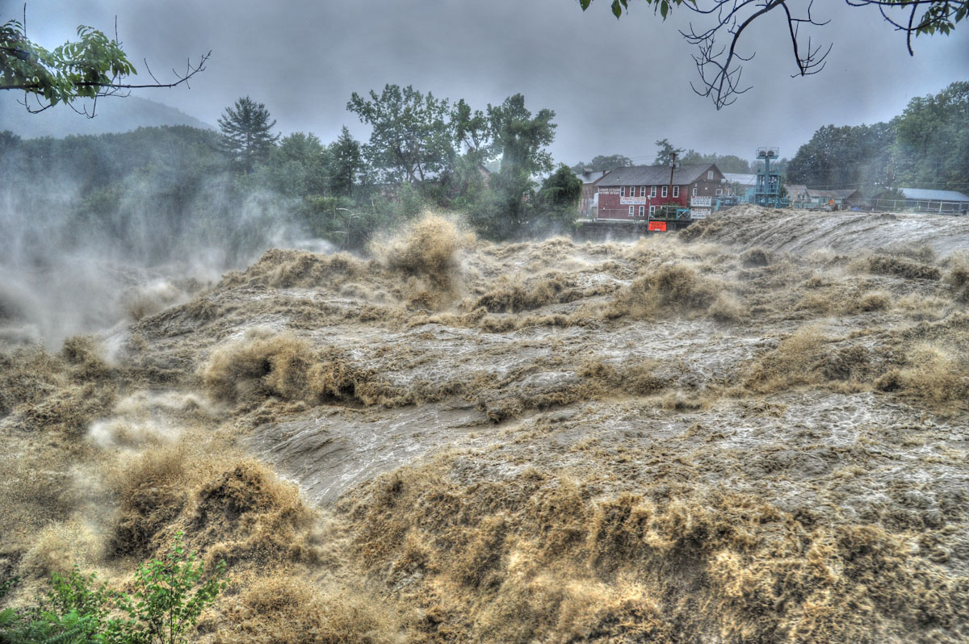
Deerfield River flooding near Shelburne Falls, MA, 2011

7. TOP PRIORITY Hazards FOR DEERFIELD
The Deerfield Community Resilience Building (CRB) workshop identified four top priority hazards for the town, based on the information presented above, and the input of workshop participants. The top four priority hazards include:
- tornados and windstorms;
- hurricanes and tropical storms;
- floods and dam failures; and,
- severe winter storm and ice storms.
This ranking was based primarily on the frequency, severity, and extent of damage from previous storm or weather events, as described in the preceding sections of this report. Deerfield was heavily impacted by flooding from Tropical Storm Irene in 2011, so this hazard was a particularly important issue for the town.
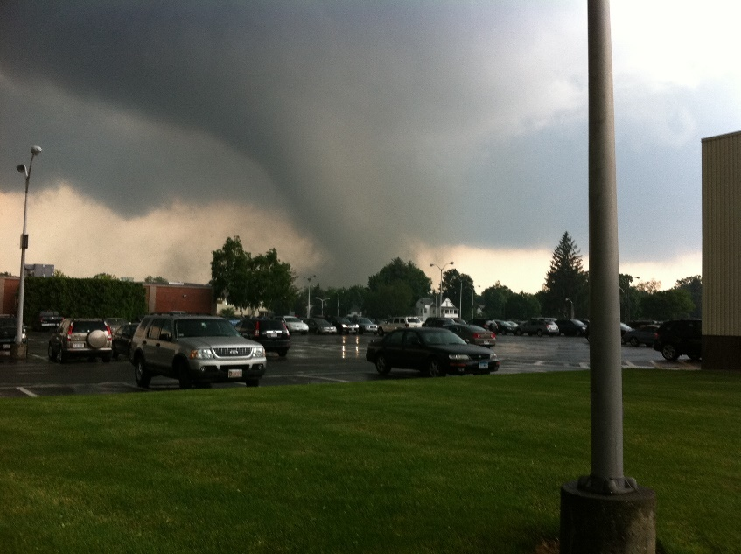
Tornado in downtown Springfield

8. Strengths and VULNERABILITIES
The Deerfield Community Resilience Building (CRB) workshop identified the town’s key strengths, assets and vulnerabilities in relation to top priority hazards. Some features were identified as both strengths and vulnerabilities. Full copies of the CRB Risk Matrix are included in Appendix C. The strengths and vulnerabilities identified are also summarized here.
8a) Strengths/Assets
Key strengths and assets in natural hazard preparedness, hazard impact mitigation, and climate change mitigation were identified by CRB workshop participants in Deerfield, and included:
- Sugarloaf State Park and Connecticut River Greenway State Park - These parks protect Connecticut River floodplain lands and other environmentally sensitive areas.
- Deerfield Water Protection Zoning District - This overlay zone protects land in the reservoir watershed from development.
- Agricultural Preservation Restrictions - APRs are important land protection tools that permanently protect farmland in floodplains from development. This tool needs to be used more expansively, particularly along the Deerfield River in Old Deerfield and West Deerfield;
- Creating Resilient Communities Group - This committee helps to coordinate the efforts of 20 communities along the Deerfield River using a watershed-based approach to protect flood storage areas, particularly along tributaries like the North and South Rivers.
- Solar Arrays - Locally generated solar power mitigates greenhouse gas emissions by providing renewable energy.
- UMass Farm - This farm helps protect the Connecticut River floodplain from development.
- Fuller Swamp - This wetland area serves as an important flood storage area.
- Franklin Medical Center - Located in Greenfield, this medical center should be used to establish a center for special medical needs and could promote better communication between town Fire Departments and emergency medical services.
- Franklin Regional Transit Authority - Also located in Greenfield, this public transit agency is an asset for evacuation.
- Emergency Shelters -Shelter sites are an asset in storm events, and are established at Frontier Regional High School, Deerfield Elementary School and South Deerfield Fire Department.
- Flood Storage Areas - There are substantial natural flood storage areas along the Deerfield River, including farmlands, Deerfield Academy playing fields, and floodplain areas in upstream communities. There is a need for an multi-community effort to protect these areas, through agreements with neighboring communities, and use of tools like APR and NRCS farmer floodplain agreements and payments.
- Joint Pioneer Valley Mosquito Control District - This regional initiative to reduce mosquitoes and habitat can also provide joint benefits of improving flood drainage in swampy areas.
- CodeRED or Reverse 911 - Deerfield has in place a contract with the Emergency Communications Network to deliver Emergency Notification Messages through the CodeRED high-speed notification system, which provides town officials with the ability to quickly deliver messages to targeted areas of town or townwide about emergencies, including weather events. There is a need to expand this system to include more residents and more cell numbers.
- Frontier Community Access Television (Cable TV) - Another asset in delivering messages about weather events.
- Faith Community - Can be a helpful partner in providing shelters or other support in weather disasters.
- Fire, Ambulance, DPW Garage: These can provide emergency shelter and support emergency communications.
8b) Vulnerabilities
Key vulnerabilities in hazard preparedness and impact mitigation that were identified by CRB workshop participants in Deerfield included:
- Deerfield Water and Wastewater Treatment Plants - These plants need bank stabilization and armament, flood proofing of emergency generators and buildings, and installation of emergency generators where they are not installed.
- Great Hydro Dams Upstream on Deerfield River - There is a need for an emergency communications plan to give towns better notification of pre-storm dam releases or dam failures. There should be penalties and liability for failure of Great Hydro to adequately notify towns.
- Culverts - There is a need to replace culverts on Route 5/10, Wapping Road, Mill Village Road North, and Broughams Pond Road with open bottom culverts.
- Vulnerable Neighborhoods - There are several floodprone neighborhoods, including Old Deerfield and the Bloody Brook area, as well as elderly housing that greater need for flood warnings and flood prevention.
- Businesses with Hazardous Chemicals - Businesses such as Pelican Products, Crop Production Services, Trew Stone and Yankee Candle that handle larger quantities of hazardous chemicals should continue pro-active training for disasters.
- Private and Public Schools - The many schools in Deerfield, including private schools like Bement, Eaglebrook and Deerfield Academy, should create contingency and evacuation plans, and should be considered for use as shelters and emergency supplies stock points.
- Gas Stations - There are concerns about release of hazardous chemicals in floods or severe weather.
- Melnik Farm Methane Digester - There are concerns about release of hazardous chemicals in floods or severe weather.
- Municipal Water Supply Wells - The town wells, under districts jurisdiction, are located close to rivers, are vulnerable to flooding, and need emergency generators.
- Stillwater Bridge - This bridge over the Deerfield River is vulnerable to flood damages.
- Old Deerfield village including museums and schools - The village is close to the Deerfield River and experiences periodic flooding when the river overflows.
- Septic Systems in homes near Old Deerfield - Some septic systems near Richardson’s Candy Kitchen (Routes 5/10) are impacted by flooding.
- East Deerfield Railyard - Located along the Connecticut River near the mouth of the Deerfield River, this railyard has hazardous materials subject to flooding impacts.
- Buildings Subject to Flooding in Bloody Brook Drainage - This drainage is impacted by chronic flooding of buildings. Better FEMA flood maps are needed to require floodproofing of buildings in construction.
- Evacuation and Emergency Communications Plan - Deerfield needs more robust, up-to-date evacuation plans, and needs a central communication system on road flooding.
- Deerfield and Connecticut Riverbanks, Bloody Brook - The banks of the Deerfield River were reduced in elevation due to Hurricane Irene flooding, and there is a need to reinforce and restore riverbanks and to restrict vehicles from driving to the river and eroding banks.
- Farmland and Farming Practices - Flooding and runoff cause farm pollutants such as fertilizers to be washed into the river. There is a need to promote more no till agriculture to reduce phosphorus and nitrogen pollution.
- Small Dam - There is a small, unnamed privately owned dam that needs removal in town.
- Power Lines - The town should work with utilities to move power lines underground, starting in priority areas like the Route 5/10 corridor. A tree management plan is needed along powerlines.
- Roads in Floodplain -: There is a need to protect floodprone roadways, including Routes 5/10, Mill Village Road and Stillwater Road, by replacing culverts, raising riverbanks, and raising the level of roadways.
- FEMA Floodplain Maps - The town’s federal floodplain maps are badly outdated, and need to be updated using LiDAR technology and climate change data.
- Floodprone Structures - Structures in floodplains that have been subject to repeated flooding need to be relocated.
- Beaver Dams - These need regular monitoring of their condition, to predict possible downstream flooding in case of failure.
8c) Combined Strengths and Vulnerabilities
Some features were identified by CRB workshop participants in Deerfield as both strengths and vulnerabilities, and these included:
- East Deerfield Railyard/ Amtrak Rail Line - There is a danger of chemical explosions at the railyard where hazardous chemicals are stored in a flood zone. The Amtrak line is a potential evacuation route.
- Trees - Trees are an asset in that they reduce greenhouse gases and provide shade, but also can be a hazard in storms. There is a need for a DEP-approved tree stockpile site in town, possibly on private farmland or in the Montague Plains.
- I-91 Bridge, Stillwater Bridge, Routes 5/10 - These are important parts of transportation infrastructure and evacuation routes. But they were severely impacted during Hurricane Irene, and monitoring of flood/tree debris is needed, as well as setting emergency protocols for evacuation route alternatives in case of flooding or damage.
- Private and Public Schools - These include Bement, Eaglebrook, Frontier, Deerfield Academy and Deerfield Elementary. They can provide shelter in emergencies. There is a need for better communications with Great Hydro, notification of dam releases or failures, as well as evacuation planning and drills at schools for dam failures.
- Senior Center and Town Halls - They can provide shelter in emergencies, but are also vulnerable to flooding.
- Floodplain and Riparian Areas - These are vulnerable assets that need protection. There is a need to protect Deerfield River farmland, using NRCS farmer floodplain payments and APR restrictions. There is a need to re-establish pre-Tropical Storm Irene riverbanks and improve floodplain mapping and zoning.

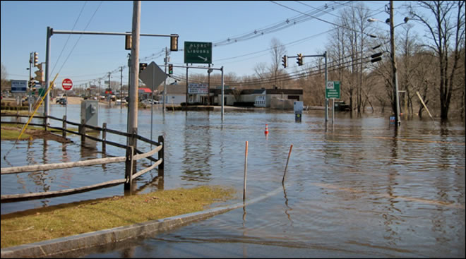

9. Climate Resiliency strategies
In preparing the CRB Risk Matrix, workshop participants in Deerfield identified current concerns and challenges presented by top priority hazards. These were then prioritized into a list of the top ten recommendations to improve resilience for the Town of Deerfield.
9a) Strategies from Original Deerfield MVP Plan
The South Deerfield CRB workshop reached a consensus on its top-ranked recommendations to improve resilience, shown below in order of priority:
- Replace Culverts - The town has prioritized culvert replacement at four locations:
  - Route 5 (near Richardsons Candy Kitchen);
  - Wapping Road (north of Greenough Crossing Road);
  - Broughams Pond Road (west of intersection with Old Ferry Road); and
  - Mill Village Road (south of intersection with Log Plain Road).

In designing the replacement culverts, consideration should be given to open bottom culverts to improve flow and fish/wildlife passage.

- Develop an Emergency Action Plan (EAP) – An EAP is needed to address better communications and evacuation planning for potential dam failures or releases from upstream Deerfield River dams, in cooperation with Great River Hydro. Improve communications between Great River Hydro and towns regarding pre-storm dam releases and impending dam failures. Great River Hydro should set up a better communications system and coordinate evacuation drills. The Town has concerns about Harriman Dam releases, including erosion and riparian buffer damages.

- Protect Flood Storage Areas - Use a watershed approach in working with upstream communities and improving participation in the state’s Agricultural Preservation Restriction (APR) program in town. Farmland that is located in Deerfield’s 100-year floodplain is likely eligible for funding through the APR Program, provided it is primarily comprised of “prime” and “state important” soils.

The primary land conservation target areas in Deerfield’s flood zone where much land conservation work remains to be done are:
- the north and south meadows of Old Deerfield;
- along the Deerfield River in west Deerfield;
- some farmland conservation opportunities also exist in the Bloody Brook watershed.
Deerfield should protect riverfront buffer areas, and ensure flood access to the floodplain, with the goal of decreasing the velocity of floods. A key issue in land conservation in floodplain areas is finding development value that can be purchased. Provided that a landowner can prove appraised value, development rights can be purchased on farm or open space parcels.
The best options for sources of funding are:
- APR Program;
- other state funding sources (e.g. MA Fish and Game and PARC grants) aimed at land conservation for such things as wildlife;
- Other federal funding sources (e.g., U.S. Fish and Wildlife Service and Federal Land and Water Conservation Funds)
- Community Preservation Act funds, which can also be an effective local match for state grants;
- private fundraising;
- Commonwealth Conservation Land Tax Credit, through which the state will grant a tax credit (not a classic tax credit; in this case the state hands over a check) to a landowner who donates or bargain sales an interest in their land (fee, CR or APR) to a qualified entity (i.e. land trust, town, state) of 50% of the appraised donative value of the interest or $75,000, whichever is less. Such a donation may also qualify a landowner for a federal tax deduction.
- Municipal Vulnerability Program
- Other parternships with state, federal, and land trust agencies

These programs need to be promoted in Deerfield, and landowners educated on the benefits.

- Establish and Implement a Mosquito Control District - This regional initiative to reduce mosquitoes and habitat can also provide joint benefits of improving flood drainage in swampy areas, including removal of debris and silt from drainage ditches and facilities in many areas of town.
- Improve and Increase Participation in the Reverse 911 Warning System - Deerfield has in place a contract with the Emergency Communications Network to deliver Emergency Notification Messages through the CodeRED high-speed notification system, which provides town officials with the ability to quickly deliver messages to targeted areas of town or townwide about emergencies, including weather events. There is a need to expand this system to include more residents, businesses and more cell numbers.

- Advance and Coordinate Emergency and Evacuation Plans - Between the town and private schools, such as Bement School, Deerfield Academy and Eaglebrook. This is of particular concern in relation to the upstream Deerfield River dams, such as the Harriman and Somerset Dams in Vermont, which could be subject to pre-storm releases or cascading failures. There is a need for better communication and notification protocol with Great Hydro, the dam operator, and for penalties or liability for failure of Great Hydro to notify the town of releases or dam failures. There is a need for evacuation planning and regular drills in the private schools.

- Implement No-Till Farming - Throughout town to reduce agricultural non-point pollutant runoff to waterways and reduce climate impacts.

- Carry Out a Utility Undergrounding and Tree Management Program to Bury Power Lines - Work with Eversource on a phased undergrounding program for electric lines, focusing first on the Route 5 corridor.

- Petition FEMA to Update the Town’s Floodplain Maps – FEMA has indicated that Deerfield’s floodplain maps will be updated soon. The town should request that FEMA use the latest LiDAR technology and climate data in this map update. This request should be made through Congressional representatives and in concert with other western Massachusetts communities. Updated floodplain maps can also be used to support improved floodplain zoning.

- Floodproof the Town’s Wastewater and Water Treatment Plants - Armoring these plants, in particular generators, against flood damages and providing emergency generators if not already in place.

9b) Updated Top Strategies to Improve Resilience

High Priority Projects

- Implement Recommendations from Sugarloaf and Bloody Brook Watershed Analysis
GZA and Field Geology will recommend improvements to address flooding and drainage problems in the Sugarloaf and Bloody Brook watersheds. These recommendations should be prioritized for upcoming MVP Action grants.
- Upgrade priority culverts in Bloody Brook watershed, including:
  - Pleasant Street culvert
  - Lower railroad culvert near Conway Street
  - North Main Street
  - North Street crossing with removal of unprotected natural gas line
- Upgrade priority culverts in Blacksmith Brook watershed, including:
  - Sugarloaf Street culvert
  - Kelleher Street culvert, which is crushed
- Work with property owners to reduce leaf and lawn debris disposal in Bloody and Sugarloaf Brooks, and to remove existing streamflow blockage.
- Seek to achieve a 50% reduction in runoff from paved areas by reducing paved areas.
- Stormwater: reduce impervious cover, promote infiltration, manage near the source
- Wetland restoration/floodplain reconnection: remove historic floodplain fill
- Vegetated riparian buffers
- Channel maintenance (dredging)

- Prepare Design Plans for Top Priority Culvert Replacement Projects
Prepare engineering design plans for the replacement of Deerfield’s top priority culverts. These culverts are: 1) Pleasant Street at Bloody Brook; 2) Sugarloaf Street at Sugarloaf Brook; 3) River Road culverts 25i and 25o; 4) Lower railroad culvert near Conway Street at Bloody Brook; and 5) Upper Road near railroad trestle. (NOTE: Some of these culverts were also identified by GZA and appear in project #1 above).

These culverts would be replaced with large armored culverts sized for increased flows expected with climate change, and allowing for fish and wildlife passage. In addition to MVP Action Grants, Deerfield should also seek funding under the U.S. Natural Resources Conservation Service’s PL566 program, MassWorks, Rural Development Fund and DER’s Culvert Replacement Grants.

- Green Streets and Parking Lots
  - Reduce Paved Areas in Town Center and Replace with Green Streets
Set overall goal of reducing pavement by 50% in the town center and reclaiming areas as green, including North Main Street, the paved areas near Town Common, and the many commercial parking areas. This will also serve as street beautification.
- North Main Street could be reconstructed with a green drainage bioswale in the median.
- Public buildings in the town center, including the Elementary School and High School parking lots, could have parking and driveways replaced or constructed with permeable pavement or materials.
  - Green Infrastructure Installation at Town Library and Town Campus:
Design green infrastructure such as tree box filters, stormwater infiltration rain gardens, EV charging stations, as stormwater and landscape amenities to complement the parking areas. This will also be a great educational location.
  - Green Streets/Complete Streets Visioning for Town Center
Coordinate a townwide visioning session to engage residents and businesses in creating a vision and design plan for South Deerfield town center that includes new green streets landscaping and stormwater features, and new pedestrian and bike friendly complete streets features. This would help guide a state Green Streets/Complete Streets grant application.

- Healthy Soils Implementation Strategies
Work with the Planning Board to implement the strategies to protect priority soils recommended in the town’s adopted Healthy Soils report, including transfer of development rights and tree preservation strategies.

- Protect Key Floodplains: Implement Deerfield River Land Preservation Plan
Working with Franklin Land Trust, complete preparatory work with landowners to purchase development rights or conservation restrictions on lands in the Deerfield River floodplain, that were identified as priorities for protection in the Deerfield River Land Preservation Plan, which was funded previously by MVP.

Medium Priority Projects

- Flood Resiliency for Historic Deerfield Wastewater Treatment Plant
As part of the planned upgrade to the Historic Deerfield wastewater treatment plant, undertake engineering assessment and design of flood resiliency features needed at the plant, including increasing tank walls and floodproofing electrical components.

- Seeding, Training and Education Program for Climate-friendly Lawns and Pollinator Meadows
Conduct a public outreach, education and training program to promote the reduction of large lawns and their replacement with meadows and pollinator gardens to reduce mowing, herbicide and fertilizer use. Purchase bulk seeds for free distribution to students and residents participating in program. Conduct demonstration and training projects at Sugarloaf Condos and Deerfield public schools with in-kind labor from residents and students. Provide signage for new pollinator gardens created throughout town.

- Address Flooding at Deerfield Inn Area in Historic Deerfield
Undertake engineering analysis to identify solutions to flooding problems impacting the Deerfield Inn and Deerfield Academy in Historic Deerfield. The stormwater drainage system located behind the Deerfield Inn appears to be undersized, and becomes overwhelmed and clogged in larger storm events, in several events causing substantial property damage.

- Municipal Tree Nursery and Planting Program
Establish a town owned and operated tree nursery on North Main Street to grow trees for free distribution and planting throughout town. Diversify the town tree belt beyond just maples to address changing climate impacts on tree species. Consider acquiring inexpensive seedlings and engaging high school students.
- Designate Deerfield Elementary School as Emergency Shelter and Seek Grants for Solar Installation
Work toward meeting necessary requirements to make Deerfield Elementary School a designated Emergency Shelter, such as installation of showers, so that the school can qualify for grants for solar panel installation. The Town of Orange, MA achieved this for the Fisher Hill School project, as an example.

9c) Strategies from Deerfield Healthy Soils Plan
This section will recommend and describe strategies that the Town of Deerfield can employ to preserve, protect and better manage its soils to promote carbon sequestration and healthy soils.
Analysis and mapping of soil conservation values in Deerfield by Regenerative Design, in this report, has shown that the highest priority soils for preservation, based on soil organic carbon stocks, are in order of importance:
- Wetland soils
- Forest soils
- Agricultural soils
- Turf soils
The strategies identified in the table below are targeted toward preserving these specific areas of healthy soils, while directing new development to areas of town with more degraded soils.

Table 1. Healthy Soils Strategies for Deerfield
ISSUE | STRATEGY | LEAD ENTITY
Protecting wetlands soils | Local Wetlands bylaw with improvements to create larger buffers* | Conservation Commission
Protecting upland forest soils | Forest uplands zoning overlay district*  Tree protection bylaw (see Significant Trees bylaw)*  Broader use of the Community Preservation Act (CPA) to preserve open space  Collaboration with land trusts to preserve key parcels  Open space grants to preserve key parcels  Creative Development zoning bylaw to promote cluster development with open space protection* | Planning Board  Planning Board  Community Preservation Committee  Open Space Committee  Open Space Committee  Planning Board
Protecting agricultural soils | Transfer of Development Rights zoning bylaw *  Broader use of CPA to promote APRs  Collaboration with land trusts to preserve key parcels  Open space grants to preserve key parcels | Planning Board  Community Preservation Committee  Community Preservation Committee  Open Space Committee
Construction impacts to soils | Post construction soil performance standards* | Planning Board
Protect and re-forest river corridors, riparian areas | River protection overlay zoning  Incentives for farmers to re-forest riparian corridors | Planning Board  Healthy Soils funds, via Conservation Districts
Minimize solar development impacts | Increase incentives for solar projects on rooftops, parking lots, roadsides, and brownfields and other already altered sites and to reduce or eliminate incentives for important natural and working lands.  Incentivize multi-use solar development on agricultural lands when it has clear benefits for farm viability and soil health. Solar grazing and solar cropping are examples of beneficial dual use. | Planning Board  Planning Board
*Note: See model bylaw for this strategy in appendix.
This plan will focus on the following recommended strategies for Deerfield:
Transfer of Development Rights
This TDR zoning bylaw would establish two zones: a Sending Zone and a Receiving Zone. It would establish a Speical Permit process allowing the transfer of development rights from the Sending Zone to the Receiving Zone. The Sending Zone would be comprised of prime agricultural lands and upland forest areas. The Receiving Zone would be comprised of existing village centers, commercial and industrial districts and other areas of degraded soils.
The bylaw would direct development toward previously developed and degraded soils (Receiving Zones) by offering incentives (i.e. increased density, lot coverage, building height, or reduced parking or setback, or options for mixed use). In return for these incentives, and applicant would purchase and preserve the development rights for a parcel(s) in the Sending Zone, or make a financial contribution to a town open space fund.
The model TDR bylaw in the appendix would also establish a Mixed-Use Village Center receiving zone with regulations and incentives to promote more compact development with a mix of residential and commercial uses in the same building(s) in the town center.
Post Construction Soil Performance Standards
Naturally occurring, undisturbed soil and vegetation provide important stormwater functions including: water infiltration; nutrient and pollutant adsorption; sediment and pollutant biofiltration; water interflow storage and transmission; and pollutant decomposition. These functions are largely lost when development removes native soil and vegetation and replaces it with minimal topsoil and sod.
Post Construction Soil Performance Standards would apply to all disturbed areas within the limits of the site which are not covered by an impervious surface, incorporated into a structural stormwater treatment practice, or engineered as structural fill once development is complete.
These standards would require:
- Retention, in an undisturbed state, the duff layer and native topsoil to the maximum extent practicable;
- Limiting total site disturbance;
- Mitigating soil compaction;
- For disturbed areas, post construction soil quality that meets standards for soil quality, including topsoil depth, minimum organic matter;
- The soil quality requirements shall be met by using one or a combination of the following methods:
  - Option 1: Leave undisturbed native vegetation and soil, and protect from compaction during construction.
  - Option 2: Amend existing site topsoil or subsoil in place.
  - Option 3: Remove and stockpile existing topsoil during grading.
  - Option 4: Import topsoil mix, or other materials for mixing, including compost, of sufficient organic content and depth.
- Plantings to replace vegetation removed during construction.

Upland Forest Protection Overlay District
Some of the most valuable and healthy soils in Deerfield are in the forested upland areas of town. An Upland Forest Protection Overlay District would be established for forested areas above an established elevation (i.e. 400 feet). It would establish regulations to protect these forest soils, including:
- Restrictions on clear cutting of forests, with selective forest cutting allowed in conformance with a Forest Cutting Plan approved in accordance with the Mass. Forest Cutting Practices Act ;
- Site plan review for all new development, except enlargement of pre-existing uses;
- Additional site plan standards within the overlay district for:
  - Minimizing tree removal during construction;
  - Erosion prevention and on-site stormwater retention;
  - Limitations on grading;
  - Designated building envelopes;
- Limits on driveway length.
- Reduced densities, and incentives for cluster development with protected open space.

Expanded Wetland and Water Resource Buffers
The soils with the highest level of carbon sequestration are soils in and around wetland areas. Protecting these soils is particularly important.
The Massachusetts Wetlands Protection Act establishes that a buffer zone is the area of land within 100 feet of coastal banks, inland banks, freshwater wetlands, coastal wetlands, tidal flats, beaches, dunes, marshes, and swamps. Work (activity) in a buffer zone could have an impact on the nearby wetland, depending on the type and location of the work and the wetland. Thus, many activities done in a buffer zone (other than minor activities set forth in the regulations and exempt activities) are subject to regulation under the Act and require prior approval by the conservation commission. A conservation commission may impose conditions or limits on activity done in a buffer zone so that the nearby wetland is protected.
In addition to the Massachusetts Wetlands Protection Act, a majority of the cities and towns in Massachusetts have their own wetlands ordinances/bylaws that provide more protections to wetlands than does the state law. The state and local wetlands laws are administered together by the local conservation commission. Work must meet the stricter of the state and local requirements. Some cities and towns also have wetlands protection requirements in their zoning ordinances/bylaws.
Many towns in Massachusetts have adopted local Wetlands Protection bylaws to expand the wetlands buffer zone. Buffer zones can be tied to zoning districts, with larger buffers around the most vulnerabile resources (e.g,. streams and pristine areas, and the default state standards in target growth areas (e.g., villages away from flood areas) Some examples include:
- Brookline - 150-ft Buffer Zone to all resource areas;
- Blackstone - 150-ft Buffer Zone if in Public Water Supply Catchment Basin;
- Bourne - increased to 200-ft for resource areas within ACEC, the Waters Resource District, or Bournedale Environmental Overlay District;
- Harvard - 200-ft Buffer Zone to rivers, ponds, vernal pools and lakes (smaller 100-ft Buffer Zone to other resource areas);
- Lancaster - extends 200-ft Riverfront Area to intermittent streams, as well as perennial.
- Framingham - 125-ft Buffer Zone to all resources areas jurisdictional to the bylaw, including Isolated Wetlands, Land Subject to Flooding and Riverfront Area.
- Great Barrington - 500-ft Buffer to public or private water supply (lake, pond, river or stream), and 200-ft Buffer to a lake or pond that is a tributary to a water supply is jurisdictional.

Creative or Context-Based Development
“Creative or Context-Based Development” is an updated version of regulations for residential cluster development with required open space protection, that can effectively reduce the impacts of urban sprawl and protect blocks of forested or farmed soils.

9d) MVP 2.0 Seed Projects
The Deerfield Municipal Vulnerability Preparedness and Climate Resiliency Core Group has identified two Seed Projects to advance the town’s flooding issues and needs.
POTENTIAL SEED PROJECT PLAN and REMAINING MVP 2.0 BUDGET ALLOCATION
PROPOSED TASK | Issue Addressed, Outcomes, Beneficiaries | BUDGET
Seed Project #1: Sugarloaf Brook Watershed Study  - Hydrologic and hydraulic study of watershed  - Geomorphic assessment of watershed  - Recommendations for addressing flooding, including identifying which culverts create the greatest risk of causing flooding and/or road damage  - Community engagement in study and results | Chronic flooding in town center  Gameplan for prioritizing and replacing culverts, reducing flooding  Residents and businesses in town center | $50,000  $7,400
- Seed Project #2: Deerfield River Land Protection  - Work with landowners to identify those willing to protect prioritized Deerfield River floodplain lands | Floodplain proetection  All residents | $5,000
- TOTALS |  | $62,400

APPENDIX A. MAP OF WORKSHOP RESULTS and MAP OF DEERFIELD LAND PROTECTION OPPORTUNITIES
APPENDIX B. DISCUSSION GUIDES

Discussion Guides
MVP 2.0 Climate Resilience Trainings
Welcome to the MVP 2.0 Climate Resilience Trainings! Each of the three sessions will take about one hour; it is recommended that you complete the trainings over three sessions. For each session, you will watch a video and then discuss what you learned with your Core Team, using the discussion guides below. Your primary vendor will help facilitate these discussions. Make sure to take notes and document your Core Team’s answers in the boxes below. Once you have completed all three sessions, email your Core Team’s completed discussion guides to your MVP Regional Coordinator.
Session 1: Previewing the MVP 2.0 Process

As a Core Team, watch the first Climate Resilience Training video (Part 1: Previewing the MVP 2.0 Process). After watching the video, discuss the questions below. Your primary vendor will help facilitate the discussion. Make sure to take notes and document your Core Team’s answers in the boxes below. It is estimated that this first session will take approximately one hour to complete.

Start with a brief round of introductions.
Before diving into the discussion, consider drafting group agreements for how you plan to work together. See the example group agreements as a starting point.

Example group agreements
- Participate as peers - Everyone comes to the group with different backgrounds and experiences. All are valued. We all speak as individuals, not as representatives.
- Share the air - If I tend to be quiet, I’m encouraged to speak. If I tend to be vocal, I’ll make sure to step back to let others speak, too.
- Create safe spaces - Let’s create a safe space to share, to learn, to say “I don’t know,” and to have honest dialogue. Keep “who says what” confidential unless given permission to share with others.

1a. What questions do you have about the MVP 2.0 process? These could be clarifying questions or bigger things you are wondering about how the process may play out. Discuss and clarify any questions as much as possible with the insight of your vendor and other Core Team members.
- There were no questions from the Core Group. Comments included: the videos were very helpful in understanding the process; Deerfield has vulnerable population with 30% of schoolchildren having food insecurity; climate change affects most those who have the least ability to adapt.

1b. What drew you to participate on this Core Team? After learning about the process, where are you excited to contribute? What knowledge, experience, or relationships do you bring? Make sure to hear from everyone on the Core Team.
Henry: He represents the younger generation, which talks about climate a lot. He is interested in social justice, as Deerfield is a privileged community but we have marginalized populations. He brings a farm background to the Core Group.
Denise: She is on the Planning Board and CCI Committee. She likes the wholistic approach here. She wants to just promote climate resiliency, but to reduce the town’s carbon footprint.
Carolyn: She is Chair of Selectboard, and a leader of the town’s MVP efforts. She is trying to get solar panels on the school roof. Feels there is a great need for grants to do climate work, as town budget is very stressed.
Laurie: She is on the Energy Committee, works in schools, is very interested in climate change, sees flooding from her home on North Main Street. She has a background in planning and energy.
Chris N: He is very interested in climate issues, feels Deerfield is more heavily impacted than other towns. The July floods highlighted the town’s impacts and vulnerable populations.
Peter: He is on the Conservation Commission, and is a lifelong environmentalist like his mom. He has 42 years of experience in environmental consulting, firsthand view of flooding. Brings a detail orientation, consulting experience.
MA: Brings energy expertise, rabid about solar, lots of town board experience, passionate about climate change, feels rural poverty is invisible and farms are very vulnerable.
Greg: Lives in town center, floods are big concern.

1c. Where do you have reservations? Are there aspects of the process that you are worried about? Make sure to hear from everyone on the Core Team.

Carolyn: Concerns that MVP 2.0 is one size fits all, very prescribed. Deerfield is very different from Boston or Cambridge. But we can learn from them. Need to modify the prescribed process to fit Deerfield.
Denise: Feels a sense of impatience with the prescribed process, wants us to stay on track.
Laurie: Maintenance of green infrastructure and spaces is an issue.
MA: Maintenance is a big issue, needs to be built into projects.

1d. What is your vision for this process? What would be a sign that this process has been successful? Make sure to hear from everyone on the Core Team. Try to focus on the process itself, and not specific project outcomes. It will be important to listen to what the community needs before knowing which project/s are best to pursue.
Chris N: Get new people involved and their voices heard.
Peter: Outreach to the broader community, and education on climate.
MA: Use education to overcome initial negative reactions to things like tree boxes.
Wayne: Inclusivity of more voices is helpful in getting grants.
1e. Take a moment to touch base on logistics. How often and in what format do you want to meet as a Core Team as you work through the MVP 2.0 process? What will make those meetings feel most meaningful and effective?
Denise: Have good agendas and stay focused. Kids are part of the vulnerable population, how to educate them? Use informational handouts to general public.
Carolyn: Take advantage of winter to get work done. Need to set meetings to include schedule for school vacations, night meetings may be needed.
Laurie: Minutes would be helpful. Subtask groups could be useful.
All: Can meet every two weeks to move process faster.

Session 2: Understanding Local Climate Vulnerability

As a Core Team, watch the second Climate Resilience Training video (Part 2: Understanding Local Climate Vulnerability). The training mentions several tools and references that can assist your Core Team in understanding local climate vulnerability. They can be accessed at the following links:

Massachusetts Climate Change Assessment: https://www.mass.gov/info-details/massachusetts-climate-change-assessment

Resilient Mass website: https://resilientma.mass.gov/home.html
- Guides for Equitable and Actionable Resilience (GEAR): https://resilientma.mass.gov/gear
- Resilient Mass Maps and Data Center (includes Resilient MA Map Viewer & Climate Change Projections Dashboard): https://resilientma-mapcenter-mass-eoeea.hub.arcgis.com/
- Climate Resilience Design Standards Tool: https://resilientma.mass.gov/rmat_home/designstandards/

Massachusetts EEA YouTube Channel: www.youtube.com/@MassEEA
- Massachusetts Coast Flood Risk Model (MC-FRM) Training Series: https://www.youtube.com/watch?v=fwJIHgixA1A&list=PLzQVK6KiTOqxwgQQ5otdUffrD4Cx6ybgh
- Municipal Vulnerability Preparedness Program Videos Playlist: https://www.youtube.com/watch?v=ozNokoMeApQ&list=PLzQVK6KiTOqzGoVpAXnLSNfD-FsdE4n00

After watching the video, discuss the questions below to practice applying these tools and resources to your planning efforts. Your primary vendor will help facilitate the discussion. Make sure to take notes and document your Core Team’s answers in the boxes below. It is estimated that this second session will take approximately one hour to complete.

Practice Exercise 1: This mini-exercise is intended to provide your Core Team with initial exposure to the GEAR tool. You will spend more time in the GEAR tool in subsequent phases of the MVP 2.0 process. Plan to spend about 15 minutes on this exercise including using the tool and the discussion. An in-depth “How To” video is available on the GEAR tool home page if you’d like to continue with further learning later.

Navigate to the GEAR tool and open a guide that seems relevant to the hazards you are experiencing in your community (e.g., Infrastructure x Inland Flooding). Look through the “Questions to Answer” in the guide. As a Core Team, answer one question using the GEAR map data layers mentioned in the guide. Note any questions that come up about using the GEAR tool.

Unfortunately, the GEAR maps do not provide inland flooding mapping for Franklin County, and that is the most critical climate impact facing Deerfield. The Core Team discussed this issue anyway, specifically the question: “Which segments of your community’s vital infrastructure are in areas at risk of flooding?”

Bloody Brook runs through the center of South Deerfield and is subject to frequent, chronic flooding. This was particularly severe in the July and December storm events this year. The Elementary and High Schools, and the town center are most at risk. Undersized culverts in the town center are major contributing factors to flood damages. The railroad culvert is also a problem, and the Selectboard will reached out to MassDOT (the owner) for help with addressing this. Four town culverts were identified in a FRCOG study as the most vulnerable, and those have been prioritized for MVP work. A lack of current FEMA Floodplain maps is a significant problem, and updates have been long delayed. Outreach to FEMA and legislators may be needed. The Stillwater Bridge has been evaluated and judged to be vulnerable, and will be replaced next year. River Road is threatened with collapse in the north end of town. The frequently flooded culvert on Routes 5/10 at Richardson’s Candy Kitchen is on the state’s list for replacement. Emergency approval for cleaning farm ditches under a DEP “Bundled Notice of Intent” helped with flooding, and may be needed in other areas.

Practice Exercise 2: This mini-exercise is intended to warm up your Core Team for Step 4: Uncovering Social Resilience, where you will use a combination of data explored in GEAR, and information you learn from the community to identify factors that contribute to vulnerability and resilience for people in the community and use that information to inform your approach to building resilience. Plan to spend about 10 minutes on this exercise including using the tool and the discussion.

As the training mentions, not all information that’s important for understanding climate resilience can be found on a map or through climate projections. Looking again at the “Questions to Answer” in the same GEAR guide, identify some stakeholder groups or community members your Core Team would need to talk to to more fully answer the questions. These groups may bring personal lived experience, technical subject matter expertise, or both.

Key stakeholder groups for social resilience in Deerfield are:
- Students/youth: There is a need to engage students at the Elementary, Middle and High Schools in climate education, curriculum. Deerfield Academy has an Environmental Club, and these students could engage with Deerfield Elementary students. Frontier students could participate in an Envirothon.
- Seniors: 45% of town residents are over age 55.
- Farmers: They are heavily impacted by flooding along Deerfield River, frost issues, heat, drought, erosion and more. A town forum could be held in January for farmers to connect them with NRCS funding programs for cover cropping, and explain Wetlands Protection Act do’s and don’ts for farmers.
- Residential areas along Bloody Brook in South Deerfield center: Heavily impacted during the July and December storm events.
Printed materials and presentations to all of these groups could increase awareness of climate issues and the town’s climate resiliency planning efforts.

Practice Exercise 3: This mini-exercise is to provide your Core Team with exposure to some of the data and tools related to climate hazards and projections. You will reference these tools at multiple phases of your MVP 2.0 Process and beyond. Plan to spend about 20 minutes on Parts A through C of this exercise.

Part A: Navigate to the Massachusetts Climate Change Assessment and open Volume III - Regional Reports for more localized information. Each Regional Report discusses “Most Urgent Impacts by Sector” (human, infrastructure, natural environment, governance, and economy). Pick a sector and review the urgent impacts. Which of these stand out to you? Why?

Our Core Group selected Agriculture as the sector to review. The urgent impacts that stand out included:
- Loss of fruit crops, such as blueberries, peaches. Help is needed for farmers to protect trees from events such as this year’s late frost that killed the year’s crop.
- Flooding of croplands along rivers, with resulting loss of crops.
- Concerns about a catastrophic dam failure, such as Harriman Reservoir, and a wall of water destroying croplands.

NRCS will have resources, and we need to help farmers understand resources and how to apply. The group agreed to hold a forum for farmers in January to review assistance programs, Wetlands regulations and energy savings programs.

Part B: Navigate to the Climate Change Projections Dashboard. Filter the data by your watershed or town and a target decade. The dashboard allows you to explore projections seasonally, using the “annual” projections for this exercise. Fill in the table noting how certain climate hazards are projected to change over time.

Climate Projection | 2030 | 2050 | 2070
Days below 32 degrees F | -25 | -48 | -68
Days above 90 degrees F | 5 | 12 | 26
Total precipitation (percent change) | 6% | 8% | 9.8%

Part C: Navigate to the Resilient MA Map Viewer. Turn on the layer for your region’s land surface temperature by selecting “Land Cover” then “Land Surface Temperature” then selecting the Land Surface Temperature Layer for your planning commission region. You can click on the “ⓘ” icon to learn about the map layer. Are there any notable high land surface temperature areas in your community?
(Note: If you are a coastal community, you may alternatively choose to look at coastal flooding by selecting “Coastal Flood Hazards” then “Massachusetts Coast Flood Risk Model” then “2070 Coastal Flooding: 1% Annual Exceedance Probability.” Where are the areas of highest flood risk in your community?)

Yes, there are several notable high land surface areas in Deerfield, which are primarily areas with lots of parking or pavement: South Deerfield town center, Deerfield Elementary School, Pelican products, the town industrial park, and Yankee Candle Co.
The town is working to reduce pavement and install permeable pavement in areas around the community.

Session 3: Building Community Climate Resilience

As a Core Team, watch the third Climate Resilience Training video (Part 3: Building Community Climate Resilience: Key Considerations and Examples). The video includes case studies and references to tools which help you turn ideas into actionable resilience projects. The referenced tools can be accessed at the links below, for future reference.

- MVP 2.0 Engagement Plan: https://www.mass.gov/doc/tool-1-engagement-plan/download
- MVP 2.0 Example Seed Projects: https://www.mass.gov/doc/mvp-20-seed-project-examples/download
- Guides for Equitable and Actionable Resilience (GEAR): https://resilientma.mass.gov/gear (within any guide, scroll to the “Actions to Consider” and “Explore MVP Case Studies” sections)
- MVP Nature-Based Solutions Toolkit: https://resilientma.mass.gov/mvp/content.html?toolkit=nature_based

After watching the video, discuss the questions below. Your primary vendor will help facilitate the discussion. Make sure to take notes and document your Core Team’s answers in the boxes below. It is estimated that this third session will take approximately one hour to complete.

3a. The case studies highlighted different types of projects — for example, Andover was assessing design solutions to prevent flooding, Mashpee developed new regulations to protect water quality, while Springfield focused on better communication and economic opportunities for its residents. What parts of those projects felt particularly exciting or meaningful to you? Why is that? What did those stories make you think about, in the context of your own community? Is this type of work already underway in your community?

Denise Mason felt that several projects stood out: building a better buffers for rivers, removing pavement, equitable solar power for low income residents, and converting impervious surfaces to green space, all seem relevant to South Deerfield center and Bloody Brook.
Carolyn Ness said that while Deerfield has no environmental justice areas, the town center is vulnerable to flooding. We need to get neighborhoods to participate. The town should do some spring training on flood events, and set up a FEMA “Recovery Team” to help residents file claims in a flood event, and have ability to respond to events.
Deerfield has had a year of severe flood damages and costs, and is trying to understand how it will cope with twice as much water as we got this year.

3b. The MVP 2.0 process focuses on input from the broader community and specifically people who will be most impacted by climate change; therefore, inclusive and equitable engagement will be key. What stood out to you in how these municipalities engaged and collaborated with community members? Why is that? What did those stories make you think about, in the context of your own community?
The team liked the approach used by the Chester Town Administrator, going door to door to speak to residents in a small town. Deerfield needs to knock on doors, and meet residents where they congregate, like the Polish Club, Senior Center, Women’s Club and library. We need to give incentives for participation, like offering direct assistance in flood preparations. Deerfield has a poor system of communication , can we improve that? We need to target interest groups, such as distributing flyers at schools.

3c. Many of the case studies didn’t just protect against a climate hazard but went further to transform ways of doing things in their community to build social resilience, restore environmental resources, and address root causes of vulnerability. Where do you see opportunities in your community to tackle climate vulnerability while also creating a stronger and healthier community in other ways at the same time?
We need to look at regional approaches with the four Frontier District towns, especially Whately, to promote communication. The message we want to convey is awareness of vulnerability to floods, especially on Bloody Brook. Focus groups are needed, including resources for farmers on drainage ditch maintenance, seeding for erosion control, fencing buffers and tillage methods.

3d. Just like the case study interviewees, take a moment to imagine your community in 50 years. What does it look like, who's there, what makes it a thriving place?
Deerfield continues to be pro-active on climate challenges that affect everyone, and comes together as a community to make changes, with better communication and education. Our vision includes a vibrant agricultural community, a walkable community, where young kids value farms, and farms thrive. We work with school curriculum coordinators on student engagement and stewardship, create partnerships with environmental centers such as Hitchcock Center. Some models include: Greenfield has a Just Roots community farm, Hawlemont Elementary has a good farm program, and Ashfield has a fresh air program for city kids.

